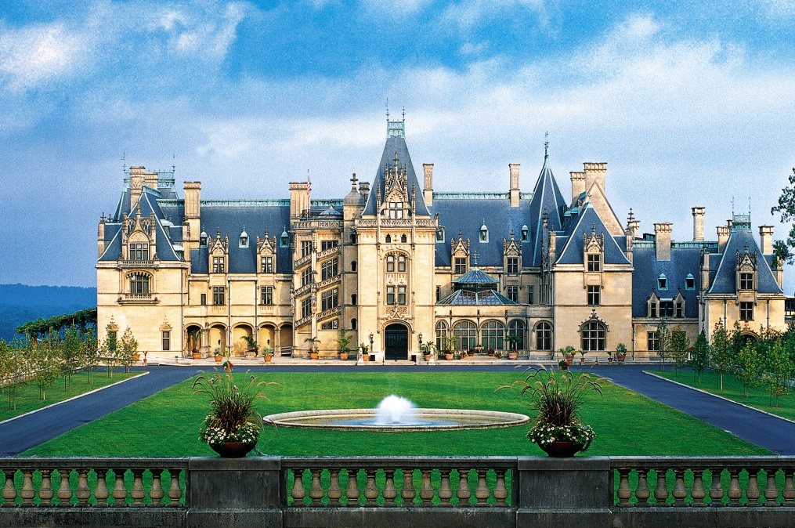
The Biltmore Estate
Location:
The Biltmore Estate is located in Asheville, North Carolina.
Interesting Facts:
The Biltmore is the largest home in America, and it has been used in many movies. The Biltmore Estate was completed in 1895. That was 118 years ago! There are 250 rooms, and they are still impressive today like they were a century ago. These rooms include a two story library and a winery. It took almost 7 years to build! The entire estate covers 8,000 acres. It is a very popular place – over one million people come to visit each year!
Activities:
- Tours of the estate and the grounds
- Carriage rides
- Horseback rides
- Bike rentals
- Fly fishing
- Ride down the French Broad river
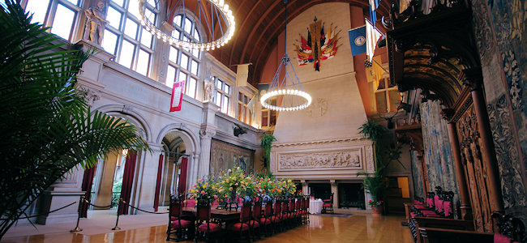
- Visit the greenhouse
Animals:
While you may not see many animals inside or right around the estate, you can see horses, birds such as geese and ducks, gray squirrels, and white-tailed deer.

