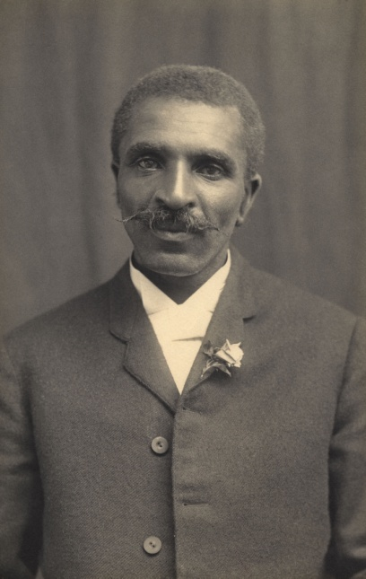
George Washington Carver

George Washington Carver was born in January 1864 and died January 5, 1943 in Missouri. He taught himself to read. He wanted to get an education. When he was 12 years old, he left home to attend a black school. There was only one teacher with 75 children in a small room. While other children played at recess, he studied. He studied at home before and after he did his chores. Soon he knew more than his teacher.
He wrote to a college to enroll and they accepted him, but when they found out he was black, they told him he couldn't attend. After five more years, when he was 30 years old, he was accepted at a college in Iowa. He learned about plants and farming.
Carver started studying diseases which were attacking the farmers' crops. He also did a lot of experimenting to find new ways to use different plants. He made more than 300 products from peanuts. He even made soap and ink from peanuts. From sweet potatoes, he made 118 products, including flour and candy. He made 75 products from pecans and even made a building material for walls from cotton stalks. He had many good ideas!

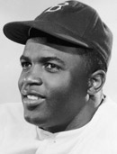
Jackie Robinson
Jackie Robinson was born in Cairo, Georgia in 1919. His mother, Mallie Robinson, raised Jackie and her four other children. They were the only black family on their block. Jackie would grow to be the first baseball player to play in Major League Baseball.
Jackie did well at all sports. He went to college but couldn’t afford it so he had to leave school and joined the US Army. In 1947, Brooklyn Dodgers asked Jackie about joining the Brooklyn Dodgers. The Major Leagues had not had an African-American player since 1889, when baseball became segregated. His first game on April 15, 1947, marked the first time an African-American athlete played in the major leagues. At the end of Robinson's first season with the Brooklyn Dodgers, he had become National League Rookie of the Year.

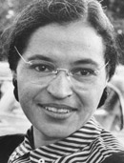
Rosa Parks
Rosa Parks was born February 4, 1913, in Tuskegee, Alabama, to James and Leona McCauley. She grew up on a small farm with her brother, mother, and grandparents.
She attended a school for African-American children. The old, one-room schoolhouse was only open five months a year and just went up to sixth grade. In 1924, at age 11, she was sent to Montgomery to continue her studies. Five years later, she left school in order to care for her sick grandmother, and later, her mother.
Rosa Parks stood up for other African Americans by refusing to give up her bus seat to a white passenger. Rosa Parks' arrest for breaking laws started a boycott of the city bus line that lasted 381 days. This eventually led to a law that said you can’t tell people they can’t ride a bus because of the color of their skin.

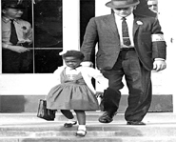
Ruby Bridges
Ruby Bridges is famous for doing something most of us take for granted today: going to elementary school. Ruby was born on September 8, 1954 in Tylertown, Mississippi. A year later, her family moved to New Orleans, Louisiana. At that time, people wanted to keep blacks and whites separate. They had separate water fountains and separate schools.
All that changed with Ruby, who was one of the first blacks to go to an all-white school. Her dad didn’t want her to go the all white school but her mom did. Ruby’s mom thought Ruby would get a better education at the all-white school.
At first, Ruby had to be taken to school by federal marshals. It took a long time for people not to be angry with Ruby. What Ruby did was so brave and helped other African Americans, making it easier for other blacks to go to white schools and get a better education.

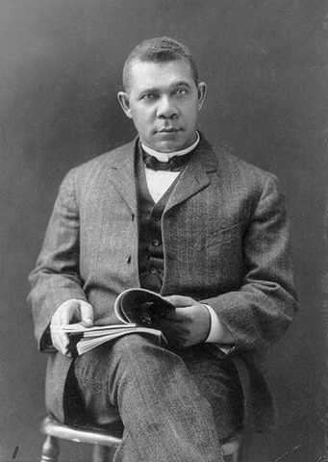
Booker T. Washington
Booker T. Washington was born a slave in Franklin County, Virginia. He was born April 5, 1856. His mother Jane was a cook for the plantation. He grew up in a small log cabin with a dirt floor. Each night a "pallet" was put on the floor for sleeping.
Booker's parents permitted him to attend school if he worked before and after school. He worked from 4:00 AM to 9:00 AM in the mines, then went to school half a day. After school he went back to the mines.
He said his first day at school was the happiest day of his life. When the teacher asked his name he said, "Booker". All the other children gave a first and last name, so Booker chose to take the name "Washington", his step-father's first name, as his second name.
He soon had to drop out of school to work full time in the coal mine. He heard about the Hampton Institute in Virginia, a school for black boys and girls. He was determined to go to the school. After graduation he returned to his hometown, Malden, and became a teacher at the first school he ever attended. He started having classes in an old church and a run-down building. When it rained, one of the taller students would hold an umbrella over the teacher's head to keep him dry.
Booker T. Washington, more than any other black man of his time, helped to elevate his people through education.
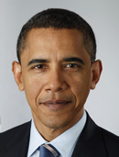
Barack Obama
President Barack Obama was born on August 4, 1961, in Honolulu, Hawaii. President Obama went to college and earned his law degree. He moved to Chicago and began teaching at the University of Chicago Law School. He joined a well-known Chicago law firm in 1993.
He was certain that he was meant to do more than just practice law so Obama decided to run for political office. He was elected to the Illinois State Senate in 1996 and served there for eight years. Then he was elected to the U.S. Senate in 2004. In 2006, Obama announced that he would be a candidate for the President of the United States. Obama was elected as the nation’s first African American president in November 2008.
President Obama is now the president of the United States of America. He lives in the White House in Washington, D.C. with his wife Michelle and two daughters, Maila and Sasha.
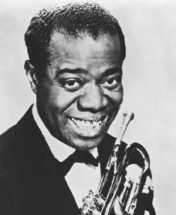
Louis Armstrong
Louis Armstrong was born in New Orleans on August 4, 1901. As a child, he sang on the streets with friends. In 1913 Armstrong was arrested for firing a gun into the air on New Year's Eve. He was sent to a special school, where he took up the cornet (a trumpet-like instrument) and eventually played in a band.
In 1922, Armstrong traveled to Chicago to perform in a band and he then moved to New York City. When Armstrong returned to Chicago in the fall of 1925, he started a band and began to record one of the greatest series in the history of jazz. Louis Armstrong was important part of American music.

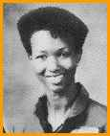
Mae Jemison
Mae Carol Jemison was born October 17, 1956. She was the first African-American woman in space. Dr. Jemison is a medical doctor and a surgeon. She was accepted into NASA's astronaut program in 1987. She flew on the space shuttle Endeavor as the Mission Specialist; the mission lifted off on September 12, 1992, and landed on September 20, 1992.
In addition to her native English, Dr. Jemison speaks Russian, Japanese, and Swahili. Jemison appeared on an episode of the TV show "Star Trek: The Next Generation" in 1993.
Dr. Jemison founded the International Science Camp in Chicago in 1994. It is a program designed to interest children in science and space.

