Blue Ridge Parkway
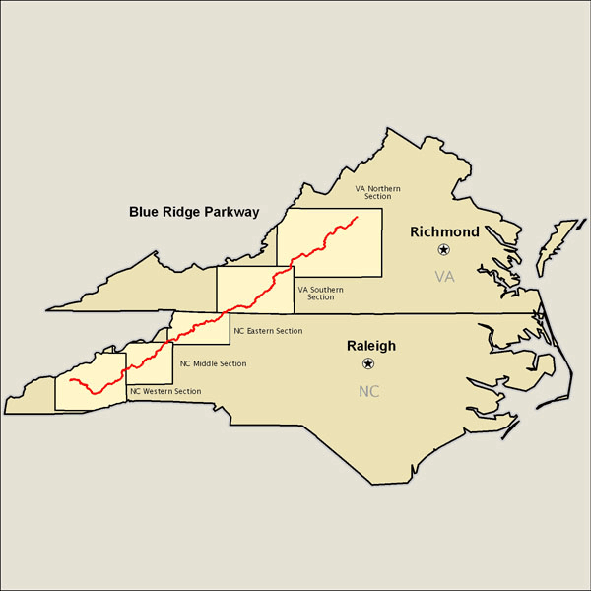
Location:
The Blue Ridge Parkway runs from Shenandoah National Park in Virginia to the Great Smoky Mountains National Park near Cherokee, North Carolina.
Interesting Facts:
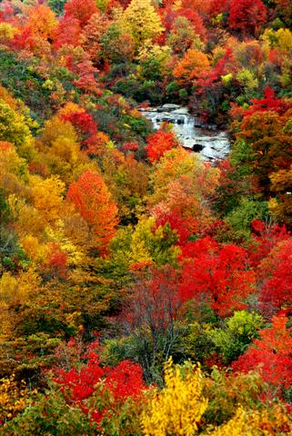
The parkway runs through the Blue Ridge Mountains, which is a part of the Appalachian Mountains. The Blue Ridge Parkway is 469 miles long! There are many beautiful things to see. May is one of the best months to see wildflowers. The best month to see Rhododendron, a beautiful plant, is June.
Activities:
- Hiking
- Guided Walks
- Visit Parks
- Horseback Riding
- Bird watching
- Historical and Cultural Demonstrations
Animals:
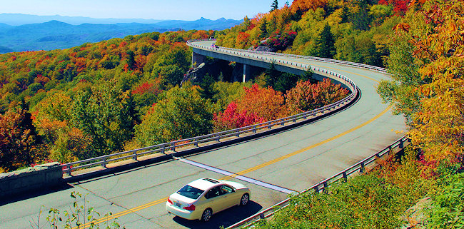
The Blue Ridge Parkway protects many different plants and animals. 74 different mammals make their homes along the Parkway, including foxes, deer, bears, bats, otters, opossums, and chipmunks. There are 31 species of salamanders along the Parkway. There are more than 250 bird species along the Parkway, including very rare species. There are also over 50 species of fish, including 6 that are rare. There are 22 species of snakes, 7 species of turtles, and 6 species of snakes.

