Book Club!
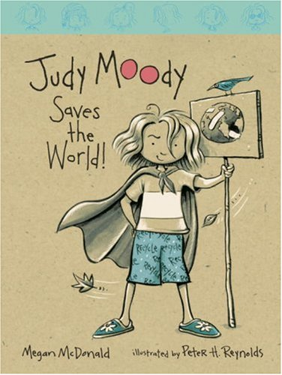

Name: ________________

- Do an online search to find more facts about a Cassowary and Picasso.

2. Design your own crazy strip. What would your slogan say?

- What do you infer Stink means when he tells Judy she looks like a goldfish in a toilet bowl?
____________________________________________________________________________________________________________________________________________________________________________________________________________________________________________

4. Research composting online. Create a flow chart of steps to show someone how to make their own compost.

- Make a list of things you can and cannot compost:
____________________________________________________________________________________________________________________________________________________________________________________________________________________________________________
- What do you infer “noise pollution” is on page 32.
____________________________________________________________________________________________________________________________________________________________________________________________________________________________________________

- What are some ways that you could help save the Earth? Sort them into the 3 R’s.
Reduce | Re-use | Recycle

8. Create your own poster for saving an endangered animal.
9. Draw your own stamp collection.

10. What do you infer these words mean (“Erosion” on page 61 and “Endangered” on page 67).
____________________________________________________________________________________________________________________________________________________________________________________________________________________________________________

11. Develop your own club. Describe what people would do and what rules would you have?
____________________________________________________________________________________________________________________________________________________________________________________________________________________________________________
____________________________________________________________________________________________________________________________________________________________________________________________________________________________________________

12. What do you infer Judy means when she says “If Stink were a poison dart frog, he would have spit poison at Judy. If Stink were a volcano, he would have spewed lava.”
____________________________________________________________________________________________________________________________________________________________________________________________________________________________________________

13. Create a list of supplies that you would need if you were going to live in a tree:
____________________________________________________________________________________________________________________________________________________________________________________________________________________________________________

14. What do you infer these words mean? “Traitor” on page 90 and “green with envy” on page 103.
____________________________________________________________________________________________________________________________________________________________________________________________________________________________________________

15. Do research on the inventor Josephine Dickson. Write down three interesting facts about this inventor.
____________________________________________________________________________________________________________________________________________________________________________________________________________________________________________
16. Explore the Ranger Rick website. Create a recommendation to a friend. Why would you or would you not recommend this website to a friend? What did you find fun and interesting about it?
________________________________________________________________________________________________________________________________________________________________________________________________________________________________________________________________________________________________________________________________________________________________________________________________________________________________________________________________________________________
17. What do you infer an “ecosystem” is? Why do you think so?
____________________________________________________________________________________________________________________________________________________________________________________________________________________________________________

