Book Club!

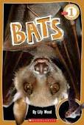

Name:

______________________________________________
Before Reading:
Know | Want to Know | Learn
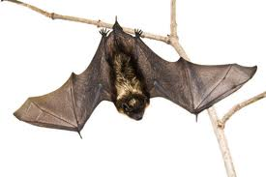
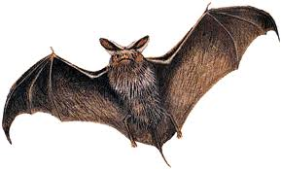
Can… | Are… | Do...

Words I can Infer:
Page Number: | Word: | I Think It Means…

Bold Words:
Choose a few words that helped you grow your schema!
Bold Word: | Definition:

Create your own Fact and Opinion game cards to play with your book club team!
Draw a picture for each place a bat can live. Label your picture.

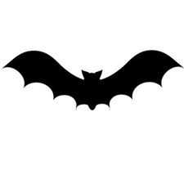Types of Bats
Go online and find an image of each type of bat and write 1 fact about them:
Long Eared Bat | Vampire Bat
_______________  ________________  ________________  ________________  ________________  ________________ | _______________  _______________  _______________  _____________________________________________

