Book Club!

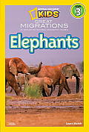

Name:

______________________________________________
Before Reading:
Know | Want to Know | Learn
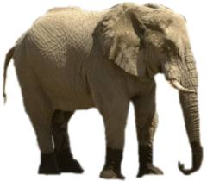
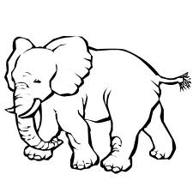
Can… | Are… | Do...

Words I can Infer:
Page Number: | Word: | I Think It Means…

Weighty Words:
Choose a few words that helped you grow your schema!
Word: | Definition:

Main Idea and Key Details!
Using the 2nd paragraph on page 38, list the main idea and key details:
Main Idea - _________________________________________________________________________________________________________________________________
Key Details:
1)_______________________________________________________________
2)______________________________________________________________
3)_______________________________________________________________
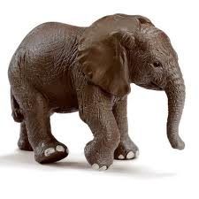
Create your own Fact and Opinion game cards to play with your book club team!
Create your own Elephant Research Book to share with the class!
Remember, each topic should be 1 paragraph and have 1 main idea sentence, 3 key details, and 1 closing sentence.
Include these key parts:
All About the African Elephant:
-
-
-
-
-
Food:
-
-
-
-
-

Growing:
-
-
-
-
-
Elephant Talk:
-
-
-
-
-
How You Can Help:
-
-
-
-
-

