Book Club!

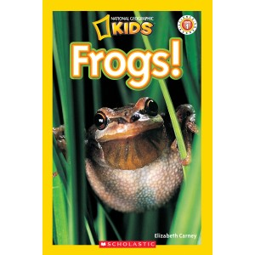

Name:

______________________________________________
Before Reading:
Know | Want to Know | Learn
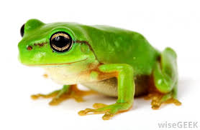
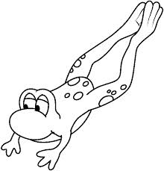
Can… | Have… | Are...

Words I can Infer:
Page Number: | Word: | I Think It Means…
Ribbit!!!
Choose a few words that helped you grow your schema!
Word: | Definition:
Habitat

Croak

Gills

Poison
Main Idea and Key Details!
Using the information on pages 6-7, list the main idea and key details:
Main Idea - ________________________________________________________________________________________________________________________________
Key Details:
1)_______________________________________________________________
2)______________________________________________________________
3)_______________________________________________________________
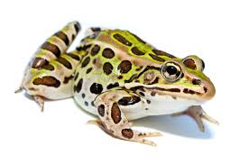
Create your own Fact and Opinion game cards to play with your book club team!
Create your own How=To Writing!
Remember, you should use the words “First, Then, Next, and Last.”
How Frogs Eat:
_________, ________________________________
_________________________________________________________________________________.
_________, ________________________________
_________________________________________________________________________________.
_________, ________________________________
_________________________________________________________________________________.
_________, ________________________________
_________________________________________________________________________________.

Frog and Toad Venn Diagram:
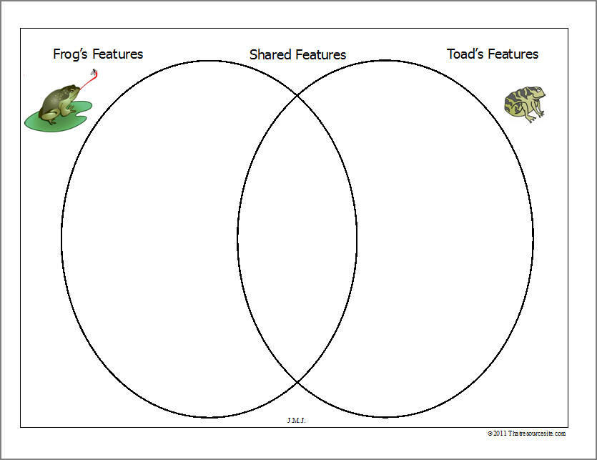

Opinion Writing:
Which frog do you think is the best?
Remember to include a topic sentence, 3 reasons, and a closing sentence.
Topic:__________________________________________________________________________________________________________1)_____________________________________________________________________________________________________________2)_____________________________________________________________________________________________________________3)_____________________________________________________________________________________________________________Closing:_____________________________________________________________________________________________________________________________________________
Draw and label the life cycle of a frog:

Draw 3 Frog Habitats:
Remember to label!
rivers ponds lakes deserts trees

Design a Comic Book cover like the one on pages 30 and 31:

