Book Club!
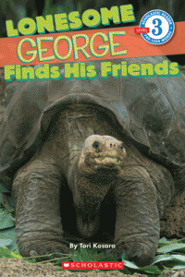

Name:________________________________

Record your Questions:
Before Reading | During Reading | After Reading
Read page 27 and write down the main idea and key details:
Main Idea:
______________________________________________________________________________________________________________________________________________________________________________________________________________________________________________________
Key Details:
1)

2)

3)

Closing: ______________________________________________________________________________________________________________________________________________________________________________________________________________________________________________________
GLOSSARY!
Look at the glossary in the back of the book. Create at least 4 sentences using the glossary words. (For instance: Cold Blooded, Climate, Nectar, Predators, or Wallow).
1)

2)

3)

4)

Compare and contrast a Galapagos tortoise and a sea turtle:
Galapagos Tortoise | BOTH | Sea Turtle

Choose one of the following animals to draw a picture of, and then label your picture with that animal’s body parts:
Dolphin Stingray
Shark Squid
Gal Frigate Bird
Fur Seal Penguin
Lava Lizard Marine Iguana

Google search a map of the Galapagos Islands, and label the continents and oceans found around them.
