Book Club!
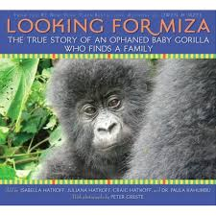

Photograph: | Caption:

Hunting and Poaching (Back of book)
Let’s make a paragraph including a topic sentence, 3-5 key details, and a closing sentence
__________________________________________________________________________________________________________________________________________________________________________________________________________________________________________________________________________________________________________________________________________________________________________________________________________________________________________________________________________________________________________________________

Inferring New Words:
My Word: | I think it means…

Sequence of Main Events:

First,

Next,

Then,

Next,

Then,

Last,

All About Gorillas!
K | W | L
