Book Club!

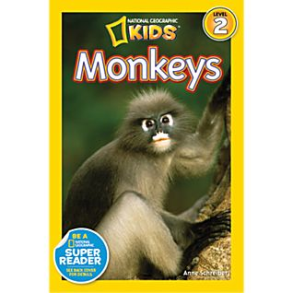

Name:

______________________________________________
Before Reading:
Know | Want to Know | Learn
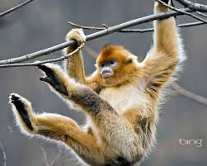
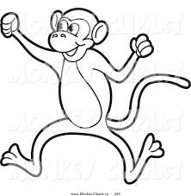
Can… | Have… | Are...

Monkey talk!!!
Choose a few words that helped you grow your schema!
Word: | Definition:
Habitat

Canopy

Prehensile

Primate
Bond

Groom

Main Idea and Key Details!
Using the information on page 21 (Tools of the Trade!), list the main idea and key details:
Main Idea - ________________________________________________________________________________________________
Key Details:
1)_______________________________________________________________
2)______________________________________________________________
3)_______________________________________________________________
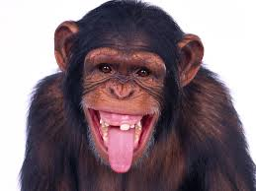
Create your own Fact and Opinion game cards to play with your book club team!
Describing Paragraph!
- Page 9 -
Describe some ways monkeys use their bodies to survive:
Monkeys bodies:
_________, ________________________________
_________________________________________________________________________________.
_________, ________________________________
_________________________________________________________________________________.
_________, ________________________________
_________________________________________________________________________________.
_________, ________________________________
_________________________________________________________________________________.

Apes and Monkeys Venn Diagram:

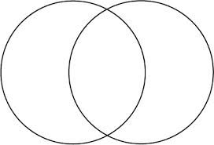

__________ __________
Opinion Writing:
Which monkey do you think is the best?
Remember to include a topic sentence, 3 reasons, and a closing sentence.
Topic:__________________________________________________________________________________________________________1)_____________________________________________________________________________________________________________2)_____________________________________________________________________________________________________________3)_____________________________________________________________________________________________________________Closing:_____________________________________________________________________________________________________________________________________________
Create your own questions like on pages 30 and 31. Shhhh! Don’t tell the answers!

1.__________________________________
a.
b.
c.
2.__________________________________
a.
b.
c.
3.__________________________________
a.
b.
c.

Draw 3 Monkey Habitats:
Remember to label!
jungles mountains grasslands rainforests

Design a Poster to help save the monkeys:
What should we do as good citizens?

