Book Club!
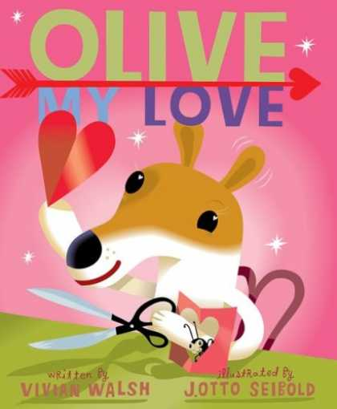

Name__________________________

Create your own LOVE song like the one Olive was singing!
___________________________________
___________________________________
___________________________________
___________________________________
___________________________________
___________________________________
___________________________________
___________________________________
___________________________________
___________________________________
___________________________________
___________________________________

Inferring!
Word to infer: | I infer (think it means)…
“Just then, down the rut rolled a nut.”

“…letting a few nuts fall from his grip…”
“The car jerked to a stop.”
“No car can make it across the steep ravine.”

Find all the “-ed” words in your story. Sort them by their sound (d, t, or ed).
“d” | “t” | “ed”

Contractions !
Write the two words that make up the contraction
don’t | +
hadn’t | +
I’m | +
that’s | +
I’d | +
you’d | +
it’s | +
we’re | +

Create a flow chart of what happened in the beginning, middle, and end of the story:

