Name: _______________
Healthy Living Problems
- Amy picked 9 apples. Sam gave her 7 more. How many apples does she have now?

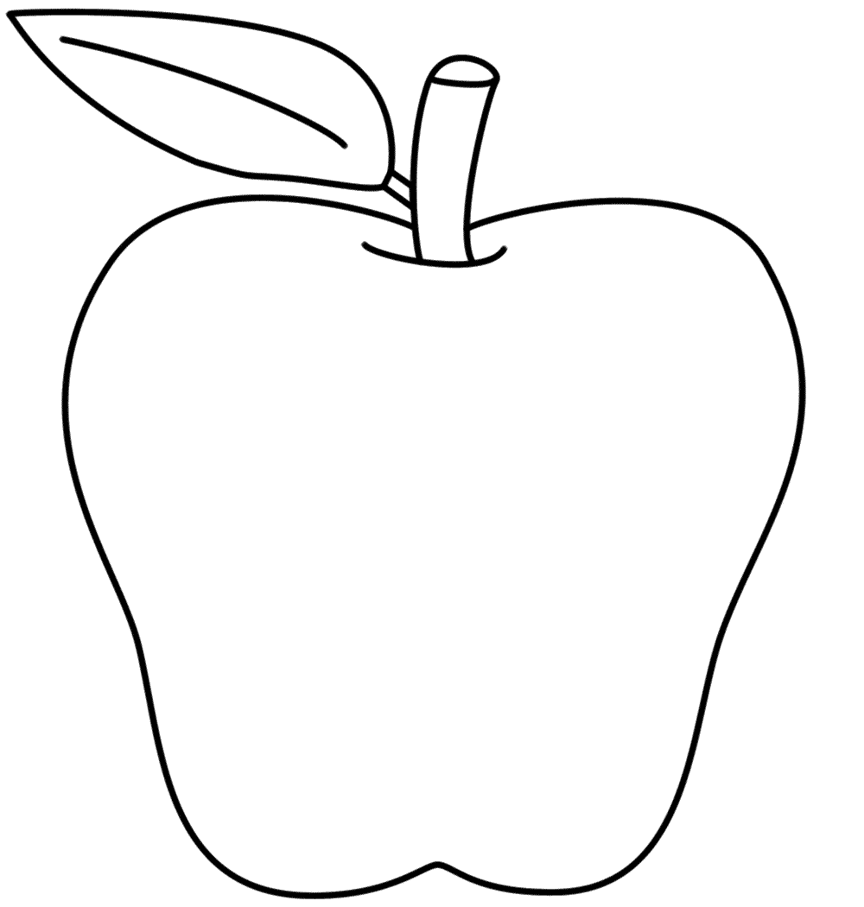

- Mike had 13 carrot sticks. He ate 5 of them. How many does he have left to eat?

- Adam picked 9 strawberries and Josh picked 8. How many strawberries did they pick together?
