Roll 2 | 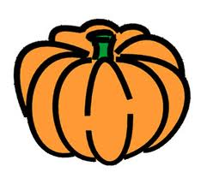  Pumpkin
Roll 3 | 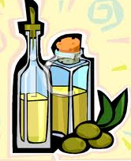  Oil
Roll 4 | 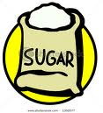  Sugar
Roll 5 | Put one item back in the pile.
Roll 6 | 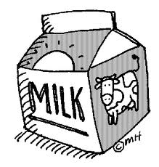  Milk
Roll 7 | 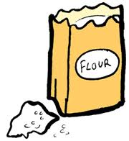  Flour
Roll 8 | Roll again!
Roll 9 | 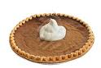  Whip cream
Roll 10 | 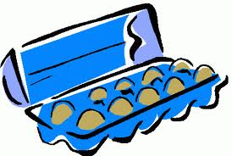  Eggs
Roll 11 | The next player gets two turns.
Roll 12 | Give another player one of your items. It must be an item that they need.

