Fluency Station**MC900351822[1]**

Questions to Ask Your Reading Partner

* What predictions did you make? Did they come true? If no, what did happen?
* Can you tell me about a text-to-self or text-to-text connection that you made while reading your book?
* What is your favorite part of the book so far? Explain.
* What part of the book made you excited? Explain.
* What part of the book caused you to [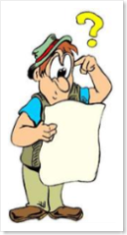](http://pearlsa.com/blog/wp-content/uploads/2007/01/WindowsLiveWriter/ConnedAboutCholesterol_F85F/confused%5b2%5d.png)confused? Explain.
* What part of the book made you  surprise? Explain.
* How would the book be different if there was a clown in the story?