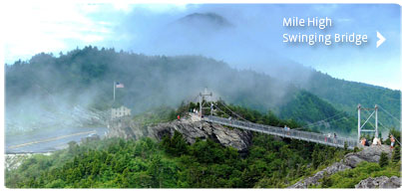
Grandfather Mountain

Location:
Grandfather Mountain is located in the Blue Ridge Mountains 19 miles from Boone, NC.

Interesting Facts:
One of the most exciting parts of Grandfather Mountain is the Mile High Swinging Bridge. The bridge was built in 1952. Thousands of brave visitors cross it every year. They are treated to a spectacular 360 degree panoramic view of Grandfather Mountain. It is also fun to hike and visit the 7 Wildlife habitats. In the habitats you can see live animals in natural environments just like they would live in the wild. It is called Grandfather Mountain because when you look at the mountain from far away, it looks like an old man asleep on his back snoring!!
.Activities:
- Hiking and walking
- Wildlife Habitat
- Nature Museum
- Swinging Bridge
- Rock Climbing and bouldering
- Fudge and Gift Shop

Animals:
Black Bears, River Otters, Cougars, White Tailed Deer, Bald Eagle

