Happy Birthday To YOU
“If we didn’t have birthdays,
you wouldn’t be you.
If you’d never been born,
well then what would you do?
If you’d never been born,
well then what would you be?
You might be a fish!
Or a toad in a tree!
You might be a doorknob!
Or three baked potatoes!
You might be a bag full of
hard green tomatoes."
“Today you are you!
That is truer than true!
There is no one alive
who is you-er than you!
Shout loud, “I am lucky to be
what I am! Thank goodness
I’m not just a clam or a ham
Or a dusty old jar of sour
gooseberry jam!
I am what I am!
That’s a great thing to be!
If I say so myself, HAPPY BIRTHDAY TO ME!”
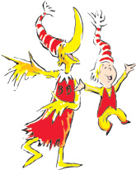
Excerpts from Happy Birthday To You by Dr Seuss

