Hooray for Fall!
Name:__________________
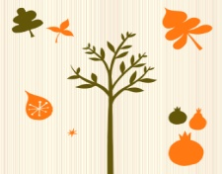
1.) Logan went on a leaf walk. He found 6 red leaves and then 4 yellow leaves. How many leaves did he find in all?

2.) A squirrel family went searching for acorns. Mother squirrel found 7 acorns and baby squirrel found 3. How many acorns did they find together?

3.) Mrs. Smith needs 6 eggs to make her famous pumpkin pie. She only has 2. How many more does she need to make her dessert?

4.) At the football game the red team scored 7 points and the blue team scored 6 points. How many points were scored at the football game?

Can you make up your own word problem? Have a friend solve it!
_____________________________________________________

_____________________________________________________

