Benjamin Franklin

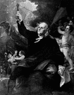
Benjamin Franklin was a curious person whose many inventions came out of a need or a perceived need. He loved to ask questions and fight the answers to those questions in experiments.
Possibly his most famous invention is electricity. He published his first writings on the subject in 1747; four years later, he published the book Observations on Electricity. He performed his famous kite experiment the very next year. He thought that metal would act as a conductor for lightning in a storm. Not really having a laboratory that could contain lightning, he had to improvise. So he did the now famous act of tying a metal key to a kite and flying both high in the air during a lightning storm. Why did he choose the kite? Well, he didn’t want to wait for lightning to strike the ground because that type of experiment could take years to complete, since lightning strikes on the ground are few and far between. So he came up with the kite as a way of getting the metal key up into the air, where lightning was more likely to strike it. He was lucky, of course, that he wasn’t killed by the jolt. His experience led him to create the lightning rod (which he envisioned for use on ships, not so much on houses) and to write the basic rules of lightning and electricity safety that are still around today. In fact, scientists today still use many ideas that Benjamin Franklin advanced beginning with that famous kite flight in June 1752.
Many of his other inventions came from a personal need or observation:
- He had bad eyesight and had to switch between eyeglasses of two different magnifications in order to read things up close or see things a little farther away. He got tired of all the eyeglasses switching, so he invented bifocals.
- During his many voyages across the Atlantic Ocean, he noticed that the ships he was traveling on could use some help in keeping water out of the lower levels. He invented a sort of watertight bulkhead (“lower compartment”).
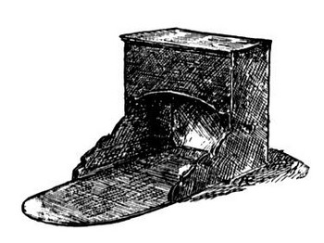
- He noticed that many people burned wood in their fireplaces even though many houses were still made of wood. He also noticed that people used a lot of wood. He came up with an iron furnace stove that used less wood while producing more warmth. It was also a safer method of heating a building. This was the Franklin stove.
- Another invention that came out of his personal observations was the odometer, a device that keeps track of how many miles a vehicle has gone. Franklin was postmaster of Philadelphia and was curious as to how many miles his postal carriage traveled on a typical day.
Although he retired from public life, Franklin still found time to invent things. Again drawing on his personal experience, he invented a long wooden pole with a metal claw on one end. He used this device to reach books on high shelves in his house.
__________________________________________________________________________

Thomas Edison

People often say Edison was a genius. He answered, "Genius is hard work, stick-to-it-iveness, and common sense."
Thomas Alva Edison was born February 11, 1847 in Milan, Ohio (pronounced MY-lan). In 1854, when he was seven, the family moved to Michigan, where Edison spent the rest of his childhood.
"Al," as he was called as a boy, went to school only a short time. He did so poorly that his mother, a former teacher, taught her son at home. Al learned to love reading, a habit he kept for the rest of his life. He also liked to make experiments in the basement.
Al not only played hard, but also worked hard. At the age of 12 he sold fruit, snacks and newspapers on a train as a "news butcher." (Trains were the newest way to travel, cutting through the American wilderness.) He even printed his own newspaper, the Grand Trunk Herald, on a moving train.
At 15, Al roamed the country as a "tramp telegrapher." Using a kind of alphabet called Morse Code, he sent and received messages over the telegraph. Even though he was already losing his hearing, he could still hear the clicks of the telegraph. In the next seven years he moved over a dozen times, often working all night, taking messages for trains and even for the Union Army during the Civil War. In his spare time, he took things apart to see how they worked. Finally, he decided to invent things himself.
After the failure of his first invention, the electric vote recorder, Edison moved to New York City. There he improved the way the stock ticker worked. This was his big break. By 1870 his company was manufacturing his stock ticker in Newark, New Jersey. He also improved the telegraph, making it send up to four messages at once.
During this time he married his first wife, Mary Stilwell, on Christmas Day, 1871. They had three children -- Marion, Thomas, Jr., and William.
Wanting a quieter spot to do more inventing, Edison moved from Newark to Menlo Park, New Jersey, in 1876. There he built his most famous laboratory.
He was not alone in Menlo Park. Edison hired "muckers" to help him out. These "muckers" came from all over the world to make their fortune in America. They often stayed up all night working with the "chief mucker," Edison himself. He is sometime called the "Wizard of Menlo Park" because he created two of his three greatest works there.
The phonograph was the first machine that could record the sound of someone's voice and play it back. In 1877, Edison recorded the first words on a piece of tin foil. He recited the nursery rhyme "Mary Had a Little Lamb," and the phonograph played the words back to him. This was invented by a man whose hearing was so poor that he thought of himself as "deaf"!
Starting in 1878, Edison and the muckers worked on one of his greatest achievements. The electric light system was more than just the incandescent lamp, or "light bulb." Edison also designed a system of power plants that make the electrical power and the wiring that brings it to people's homes. Imagine all the things you "plug in." What would your life be like without them?
In 1885, one year after his first wife died, Edison met a 20-year-old woman named Mina Miller. Her father was an inventor in Edison's home state of Ohio. Edison taught her Morse Code. Even when others were around, the couple could "talk" to each other secretly. One day he tapped a question into her hand: would she marry him? She tapped back the word "yes."
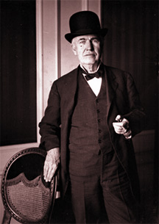
Library of Congress, Prints and Photographs Division, Detroit Publishing Company Collection.
Mina Edison wanted a home in the country, so Edison bought Glenmont, a 29-room home with 13-1/2 acres of land in West Orange, New Jersey. They married on February 24, 1886 and had three children: Madeleine, Charles and Theodore.
A year later, Edison built a laboratory in West Orange that was ten times larger than the one in Menlo Park. In fact, it was one of the largest laboratories in the world, almost as famous as Edison himself. Well into the night, laboratory buildings glowed with electric light while the Wizard and his "muckers" turned Edison's dreams into inventions. Once, the "chief mucker" worked for three days straight, taking only short naps. Edison earned half of his 1,093 patents in West Orange.
But Edison did more than invent. Here Edison could think of ways to make a better phonograph, for example, build it with his muckers, have them test it and make it work, then manufacture it in the factories that surrounded his laboratory. This improved phonograph could then be sold throughout the world.
Not only did Edison improve the phonograph several times, but he also worked on X-rays, storage batteries, and the first talking doll. At West Orange he also worked on one of his greatest ideas: motion pictures, or "movies." The inventions made here changed the way we live even today. He worked here until his death on October 18, 1931, at the age of 84.
By that time, everyone had heard of the "Wizard" and looked up to him. The whole world called him a genius. But he knew that having a good idea was not enough. It takes hard work to make dreams into reality. That is why Edison liked to say, "Genius is 1% inspiration and 99% perspiration."
For more information on Edison, check out the Edifun site from the National Parks Service
Source: National Parks Service
________________________________________________________________________

Garrett Morgan

Garrett Augustus Morgan: American Inventor
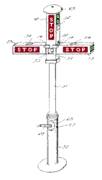
Garrett Augustus Morgan (March 4, 1877 - August 27, 1963), was an African-American inventor and businessman. He was the first person to patent a traffic signal. He also developed the gas mask (and many other inventions).
Morgan was born in Paris, Kentucky, and was the son of former slaves (and the 7th of their 11 children). His formal education ended during elementary school.
As a a teenager (in 1895), Morgan moved north to Cincinnati, Ohio, looking for opportunity. His incredible ability to repair machinery led to many job offers from factories. In 1907, he started his own sewing equipment and repair shop. His business expanded in 1909; he employed 32 people, who used equipment that Morgan made (and invented) himself.
In 1920, Morgan went into the newspaper business, starting the "Cleveland Call." He was very successful, and eventually bought a car. While he was driving along the streets of Cleveland, he realized how unsafe intersections were, and was determined to make driving safer.
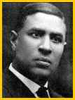
Morgan patented a traffic signal on November 20, 1923 (U.S. patent No. 1,475,024, issued in 1923) - this was the first traffic signal patented, but not the first invented. His traffic signal was a T-shaped pole with arms (but with no lights) that has three signs, one or more of which popped out at a time: a red "stop," a green "go," and another red "stop in all directions." This last signal let pedestrians cross the street. It was controlled by an electric clock mechanism. This device became very popular, and was used all around the USA. Morgan sold his device to the General Electric Corporation for $40,000 (a huge sum at that time). His device was used until the three-light traffic light was developed.
Morgan developed many other inventions, including a safety hood and smoke protector for firefighters (patent No. 1,113,675, in 1912), a gas mask (patent No. 1,090,936, in 1914). He also developed a zig-zag sewing machine attachment, a hair straightener, hair dying lotions, de-curling hair combs (patent No. 2,763,281, in 1956), and other inventions.

ALEXANDER GRAHAM BELL

Born 1847 - Died 1922
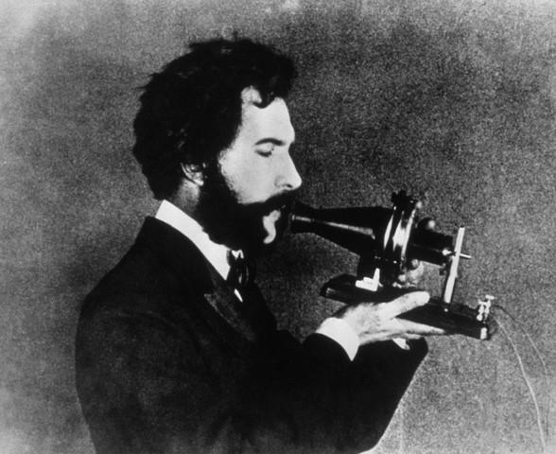

Alexander Graham Bell was born in Scotland. His mother, who was deaf, was a musician and a painter of portraits. His father, who taught deaf people how to speak, invented "Visible Speech". This was a code which showed how the tongue, lips, and throat were positioned to make speech sounds. Graham, or "Aleck", as his family called him, was interested in working with the deaf throughout his life.
He only attended school for five years; from the time he was ten until he was fourteen, but he never stopped learning. He read the books in his grandfather's library and studied tutorials * .
When he was a teenager, he and his brother Melly used the voice box of a dead sheep to make a speaking machine that cried, "Mama!" This created even more interest in human speech and how it worked.
When he was in his early 20's, his two brothers died of tuberculosis * . Bell himself had the disease and his father moved the family to Canada looking for a better climate in which to live. Bell recovered from the disease.
Two years later he went to Boston to open a school for teachers of the deaf and then became a professor at Boston University. It was at this time that he met Mabel Hubbard, one of his students who was 10 years younger than he. Mabel had become deaf at the age of four due to scarlet fever. Five years after their meeting they were married. At the wedding ceremony he gave her a gift of all but 10 shares of the stock in the newly formed company called Bell Telephone Company. They had two daughters and two sons. Their sons both died at a young age.
Thomas Watson became an associate of Bell. He made parts and built models of Bell's inventions. One day while they were working Bell accidently heard the sound of a plucked reed * coming over the telegraph wire. Watson had been tuning the metal reeds in the next room. Bell drew up a plan for the telephone and they continued to experiment. The next day he transmitted the famous words, "Mr. Watson, come here. I want you!" A few months later on Feb. 14, 1876, he applied for a patent on his telephone.
He knew he would have to work quickly to get the patent * because other people were also trying to make an invention to transmit the human voice. Elisha Gray claims he too invented the telephone, but Bell got to the patent office an hour or so before he did. It is said that Antonio Meucci also succeeded with the invention before Bell. |  | 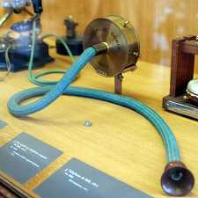  History of the telephone

Because Bell had the patent, he had the right to be the only one to produce telephones in the U.S. for the next 19 years.
He showed the invention to Queen Victoria of England and she wanted lines to connect her castles.
By 1917, nearly all of the United State had telephone service.
He continued to invent other things. He developed a method of making phonograph * records on a wax disc. He made an iron breathing lung, and a device for locating icebergs at sea. He experimented with sheep. He was interested in kites that could lift a man, and he invented a hydrofoil * which set a world speed record of over 70 miles per hour.
He along with others started the National Geographic Society and he served as its president for several years.
He became a U.S. citizen, but he died in Canada at the age of 75.

Telephone photo licensed under Creative Commons* by Rama at Wikipedia

This biography by Patsy Stevens, a retired teacher, was written in 2003.

George Washington Carver

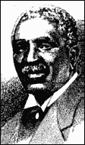 |  | George Washington Carver  Born circa 1864 - Died Jan 5 1943  Cosmetic and Process of Producing the Same; Paint and Stain and Process of Producing the Same Peanut Products  Patent Number(s) 1,522,176; 1,541,478  Inducted 1990  Agricultural chemist George Washington Carver developed crop-rotation methods for conserving nutrients in soil and discovered hundreds of new uses for crops such as the peanut, which created new markets for farmers, especially in the South.  Invention Impact  At Tuskegee, Carver developed his crop rotation method, which alternated nitrate producing legumes-such as peanuts and peas-with cotton, which depletes soil of its nutrients. Following Carver's lead, southern farmers soon began planting peanuts one year and cotton the next. While many of the peanuts were used to feed livestock, large surpluses quickly developed. Carver then developed 325 different uses for the extra peanuts-from cooking oil to printers ink. When he discovered that the sweet potato and the pecan also enriched depleted soils, Carver found almost 20 uses for these crops, including synthetic rubber and material for paving highways.  Inventor Bio  Born of slave parents in Diamond Grove, Missouri, Carver was rescued from Confederate kidnappers as an infant. He began his education in Newton County in southwest Missouri, where he worked as a farm hand and studied in a one-room schoolhouse. He went on to excel at Minneapolis High School in Kansas. Though denied admission to Highland University because of his race, Carver gained acceptance to Simpson College in Indianola, Iowa, in 1887.  Intent on a science career, he transferred to Iowa Agricultural College (now Iowa State University) in 1891 and gained a B.S. in 1894 and an M.S. in agriculture in 1897. Later that year Booker T. Washington, founder of the Tuskegee Institute, convinced Carver to come south and serve as the school's director of agriculture. Upon his death, Carver contributed his life savings to establish a research institute at Tuskegee. His birthplace was declared a national monument in 1953.

Henry Ford

Henry Ford (1863-1947)

I will build a car for the great multitude
By Mary Bellis,
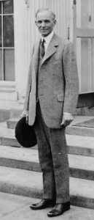
Henry Ford
LOC
More Images (2)

Automobile manufacturer Henry Ford was born July 30, 1863, on his family's farm in Dearborn, Michigan. From the time he was a young boy, Ford enjoyed tinkering with machines. Farm work and a job in a Detroit machine shop afforded him ample opportunities to experiment. He later worked as a part-time employee for the Westinghouse Engine Company. By 1896, Ford had constructed his first horseless carriage which he sold in order to finance work on an improved model.
Ford incorporated the Ford Motor Company in 1903, proclaiming, "I will build a car for the great multitude." In October 1908, he did so, offering the Model T for $950. In the Model T's nineteen years of production, its price dipped as low as $280. Nearly 15,500,000 were sold in the United States alone. The Model T heralds the beginning of the Motor Age; the car evolved from luxury item for the well-to-do to essential transportation for the ordinary man.
Ford revolutionized manufacturing. By 1914, his Highland Park, Michigan plant, using innovative production techniques, could turn out a complete chassis every 93 minutes. This was a stunning improvement over the earlier production time of 728 minutes. Using a constantly-moving assembly line, subdivision of labor, and careful coordination of operations, Ford realized huge gains in productivity.
In 1914, Ford began paying his employees five dollars a day, nearly doubling the wages offered by other manufacturers. He cut the workday from nine to eight hours in order to convert the factory to a three-shift workday. Ford's mass-production techniques would eventually allow for the manufacture of a Model T every 24 seconds. His innovations made him an international celebrity.
Ford's affordable Model T irrevocably altered American society. As more Americans owned cars, urbanization patterns changed. The United States saw the growth of suburbia, the creation of a national highway system, and a population entranced with the possibility of going anywhere anytime. Ford witnessed many of these changes during his lifetime, all the while personally longing for the agrarian lifestyle of his youth. In the years prior to his death on April 7, 1947, Ford sponsored the restoration of an idyllic rural town called Greenfield Village.

Henry Ford Trivia
On January 12, 1900, the Detroit Automobile Company released its first commercial automobile - a delivery wagon - designed by Henry Ford. This was Ford's second car design - his first design was the quadricycle built in 1896.
On May 27, 1927, production ended for the Ford Model T - 15,007,033 units had been manufactured.
On January 13, 1942, Henry Ford patented a plastic-bodied automobile - a car 30 percent lighter than metal cars.
In 1932, Henry Ford introduced his last engineering triumph: his "en block", or one piece, V-8 engine.

The T in Model T
Henry Ford and his engineers used the first 19 letters of the alphabet to name their automobiles, although some of the cars were never sold to public.

Ruth Handler

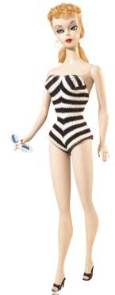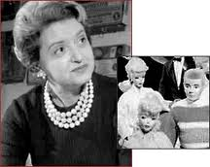
The first Barbie doll shown at New York Toy Fair in 1959.
Courtesy of Barbie Media & Mattel
More Images (3)

The Barbie doll was invented in 1959 by Ruth Handler (co-founder of Mattel), whose own daughter was called Barbara. Barbie was introduced to the world at the American Toy Fair in New York City. Barbie's job was teenage fashion doll. The Ken doll was named after Ruth's son and was introduced two years after Barbie in 1961.

Barbie Facts & Technology
The full name of the first doll was Barbie Millicent Roberts, from Willows, Wisconsin. Barbie's job was that of teenage fashion model. However, the doll has been made in versions connected to over 125 different careers.
She came as either a brunette or blond, and in 1961 red hair was added. In 1980, the first African American Barbie and Hispanic Barbie were introduced, however, Barbie did have a black friend named Christie who was introduced in 1969.
The first Barbie was sold for $3. Additional clothing based on the latest runway trends from Paris were sold, costing from $1 to $5. In the first year (1959), 300,000 Barbie dolls were sold. Today, a mint condition "#1" (1959 Barbie doll) can fetch as much as $27,450. To date, over 70 fashion designers have made clothes for Mattel, using over 105 million yards of fabric.
There has been some controversy over Barbie Doll's figure when it was realized that if Barbie was a real person her measurements would be an impossible 36-18-38. Barbie's "real" measurements are 5 inches (bust), 3 ¼ inches (waist), 5 3/16 inches (hips). Her weight is 7 ¼ ounces, and her height is 11.5 inches tall.
In 1965, Barbie first had bendable legs, and eyes that open and shut. In 1967, a Twist 'N Turn Barbie was released that had a moveable body that twisted at the waist.
The best-selling Barbie doll ever was 1992 Totally Hair Barbie, with hair from the top of her head to her toes.

Photos
- First Barbie Doll 1959
- 1961 Ken Doll
- 1960 Dream House For Barbie Doll
- 1969 Christie Doll
- 1979 Barbie Dream House
- 1980 African American Barbie Doll
- 1980 Hispanic Barbie
- 1990s Barbie Doll & Ken Doll
- 2008 Barbie 3-Story Dream House
- 2008 Barbie Doll as a TV Chef
- Sweet Talkin Ken

Rachel Zimmerman

Rachel Zimmerman

Inventor of the Blissymbol Printer
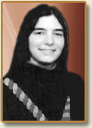
In the mid-1980s, a twelve-year old girl developed an invention that greatly helped people who have difficulty communicating. Rachel Zimmerman of Ontario, Canada created a software program using Blissymbols: symbols that enable non-speaking people, such as those with severe physical disabilities like cerebral palsy, to communicate.
The program user communicates by pointing to various symbols on a page or board through the use of a special touch pad. When the user touches the symbols, Zimmerman's "Blissymbol Printer" translates them into a written language. In this way, the user can record his or her thoughts or communicate via e-mail.
Zimmerman's system of communication started out as a project for a school science fair, but it ended up competing at the World Exhibition of Achievement of Young Inventors, winning a silver medal at the Canada-wide contest. The program also won the YTV Television Youth Achievement Award.
Rachel Zimmerman went on to study physics and space studies in college and now works for The Planetary Society in California, where she teaches people about space exploration. She is interested in combining space technology with assistive intelligence. Her goal is to take NASA innovations and tailor them to fit the needs of people with disabilities.
More Info:
Since the mid-1960s, people with severe disabilities have been learning to communicate by using a system of symbols called Blissymbolics. Charles Bliss, who aimed to create a universally understood method of communication, invented this international language, which uses pictures instead of words, in the 1940s. Canadian therapists began teaching cerebral palsy patients how to use it in the 1960s and its use among the disabled began to spread. However, until the 1980s, those users had been unable to use the system independently.
That’s when Rachel Zimmerman, then just twelve years of age, created a device known as the Blissymbol printer. The apparatus uses a software program to translate Blissymbols tapped on a board into written language on a computer screen, allowing the disabled to "talk" to others, record thoughts, write correspondence, even send emails.
Zimmerman was born in 1972 and grew up in London, Ontario, Canada. She began working on her ideas for the Blissymbol printer as a school science project. Typically, a user of Blissymbols uses a "Bliss board" to point to images of the various symbols and an assistant stays nearby to translate what the person is trying to communicate into spoken language. Zimmerman developed the idea of adding a special touch pad so that the user could simply touch the board and the software would do the translating, transmitting the output in the language of the user’s choice onto a computer screen.
Zimmerman’s concept made it possible for non-speaking people to be able to communicate in a variety of different ways, without help, for the first time. She won a silver medal for the Blissymbol printer at the World Exhibition of Achievement of Young Inventors. She also won the YTV Television Youth Achievement Award.
Since her accomplishment Zimmerman has gone on to study physics and space; she completed her college degree in 1990 and began working for the Planetary Society in California. As of this 2008 writing she is an education and public outreach specialist with NASA’s Jet Propulsion Laboratory in Pasadena, Calif.

