Book Club!

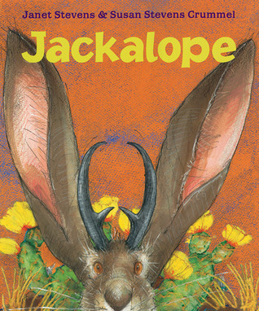

Name: ____________________________________________
Create your own family tree:

Record any words you find that have an “ed” ending:
Sounds like “t” | Sounds like “d” | Sounds like “ed”

Jackalope was given 1 wish, what 3 wishes would you choose and why?
1)

2)

3)

Draw a desert setting and label the key features you include in your picture:

What was the problem in the story and how did they solve it?
________________________________________________________________________________________________________________________________________________________________________

What lesson do you think the author wanted you to learn from Jackalope?
________________________________________________________________________________________________________________________________________________________________________
Look at some desert books and find some interesting facts about deserts:
1)

2)

3)

4)

Describe your favorite character in the story:
________________________________________________________________________________________________________________________________________________________________________

Research one of your favorite desert animals on the computer. Organize your information into categories like food, growing, parts, enemies, etc.
___________
-
-
-
____________
-
-
-
___________
-
-
-
___________
-
-
-

