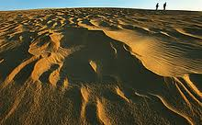
Jockey’s Ridge
Coastal Plains

Interesting Facts:
LOCATION: Jockey’s Ridge is located in Dare County in the Outerbanks (near Nagshead).
HOT! HOT! HOT! – The sand on the dunes is incredibly hot during the summer months. On average, the sand will be 25 to 30 degrees hotter than the air, so when it's 95 degrees, the sand will be 125 degrees. Remember this if you feel like going barefoot!
LIGHTNING –Lightning storms occur a lot during the summer months, especially in the afternoon. If you're on the dunes and you hear the warning siren, it means a lightning storm is coming and you need to clear the ridge as soon as you can.
Jockey's Ridge is a PROTECTED ENVIRONMENT and they do not allow any type of vehicle or four wheelers on the dunes. You can not take any animals, plants, or wildlife with you.
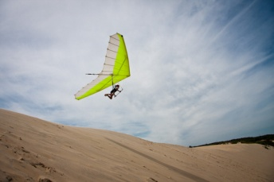
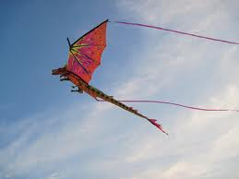
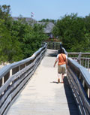
FULGURITES are hollow tubes that are made when lightning strikes the sand. If you find one, you need to let the park staff know!

Activities:
Have some fun during your stay! Go on some hiking trails, walk the boardwalk, go hang-gliding or kite flying, try sand boarding, or how about some water sports like kayaking, windsurfing, swimming!
Animals:
There are a lot of protected animals and wildlife here! You will find the Luna Moth, White-Tailed Deer, Rabbits, Opossum, red and grey foxes, Raccoons, Hognose Snakes, Six-lined Racerunner Lizards, Brown Pelicans, Snowy Egrets, Blue Herons, and Osprey.

