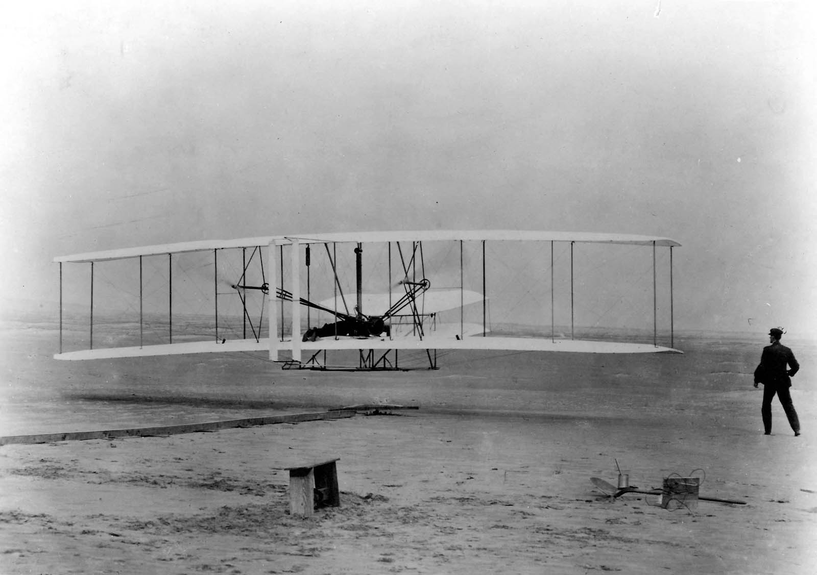
Kitty Hawk
Location: Kitty Hawk is located in the coastal region. It is a town found in the Outer Banks of North Carolina. The city of Kitty Hawk is in Dare County.

Interesting Facts: There are many stories to how Kitty Hawk got its name. Kitty Hawk is one of the largest beach communities of the Outer Banks towns. It is known as the city where the Wright Brothers spent years experimenting to fly the first airplane beginning in 1900. The city is a popular vacation spot for travelers.

Activities:
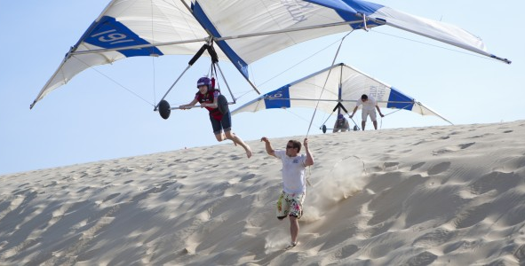
- Go parasailing.
- Walk along the beaches.
- Watch birds, dolphins, and wild horses.
- Fly kites.
- Go dune hang gliding.
- Go bike riding.
- Visit the Wright Brothers Visitor Center.
- Enjoy many water sports including kiteboarding, surfing, kayaking, parasailing, riding jet skis, wakeboarding, water-skiing, and tubing.

Animals Found Near Kitty Hawk: Birds, dolphins, wild horses, river otters, hawks, geese, ducks, swans, and many types of fish

