Linville Falls
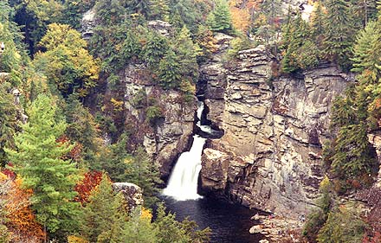
Location:
Linville Falls is a waterfall located in Linville, North Carolina. Linville Falls is in the Blue Ridge Mountains.
Interesting Facts:
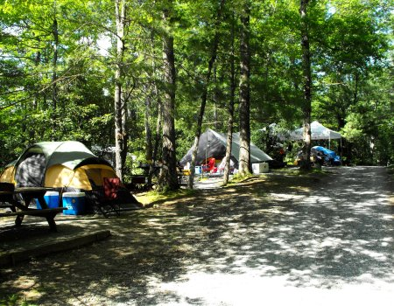
Linville Falls is named for the Linville River. Linville Falls is the most popular waterfall in the Blue Ridge Mountains. It is very close to the Blue Ridge Parkway. The height of the waterfall is 150 feet!
Activities:
- Hiking
- Birdwatching
- Swimming
- Camping
- Picnics
- Fishing
- Nature Walks
- Rafting
Animals:
There are many different kinds of animals at Linville Falls. You may see a bear, fox, raccoon, trout, grouse, turkey, vulture, owl, hawk, copperhead, or timber rattlesnake at Linville Falls.

