Sphere | 3d geometrical shape
Cube | 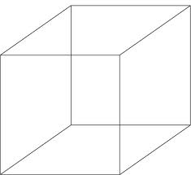 3D prism with square faces
Rectangular prism | Prism that has rectangles as bases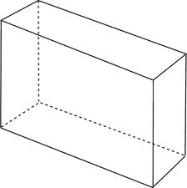
Triangular pyramid | 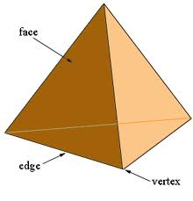  Pyramid with a triangular base
Square pyramid | 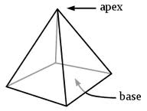  Pyramid with a square base
Cylinder | 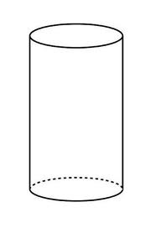  A 3-D shape with 2 circular bases.
face | A flat side of a 3-D shape
base | A side on which a 3-D figure sits.
edge | A line segment where two faces meet

