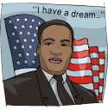
Martin Luther King, Jr.
ABC Order

____________________
____________________
____________________
____________________
____________________
____________________
____________________
____________________
____________________
____________________
Name: _____________________

Write 4 sentences using four of the words from the left.
- _________________________________________________________
- _________________________________________________________
- _________________________________________________________
- _________________________________________________________

