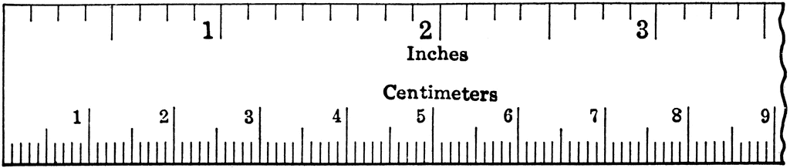
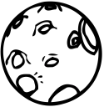
Object | CM deep | Picture of the  crater | Is this more like a meteoroid, comet/ asteroid?

