_________
Multiplication
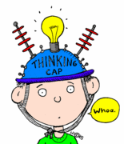
Mind-Teasers!

Scott ate 4 boxes of candy hearts. Each box had 9 candy hearts inside. How many candy hearts did Scott eat?

Number Sentence: ______________
Multiplication Sentence: ___________
Picture:

Anna bought 6 boquets of roses for her mom. Each boquet had 7 roses. How many roses did Anna give her mom?

Number Sentence: ______________
Multiplication Sentence: ___________
Picture:

Piper bought Valentine’s Day cards for her 1st grade friends. She bought 4 boxes. Each box had 6 cards inside. How many cards did she get?

Number Sentence: ______________
Multiplication Sentence: ___________
Picture:

Sharlynn bought 5 boxes of chocolate. Each box had 8 pieces of chocolate. How many pieces of chocolate did she get?

Number Sentence: ______________
Multiplication Sentence: ___________
Picture:

