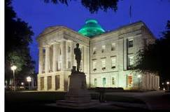
NC State Capital Building
Location: The Capital building is located in downtown Raleigh. It is on Union Square at One Edenton Street.

Interesting Facts:
Construction on the Capital began in 1833 and it was completed in 1840. The building is designed look like buildings in ancient Greece. At first, all the State leaders had offices and worked at the Capital building. Now it is only used for the Governor’s Office and staff. There are 3 stories in the capital. In the middle there is a space called the “Rotunda”. If you stand in the rotunda and look up, you can see all the way up to the dome on the top of the capital. There are 14 statues and monuments outside the Capital on Union Square.
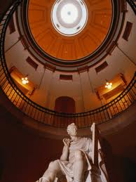
Activities:
- Tours of the Old House and Senate chambers
- Investigate the statues on Union Square
- Feed the pigeons

Animals:
Squirrels, pigeons, cardinals,

