NC Aquarium
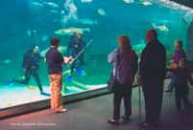
Location:
There are 3 aquariums on the coast of North Carolina.. One located in Fort Fisher, Pine Knoll Shores, and Roanoke Island.

Interesting Facts:
NC Aquariums work with the vet school at NC State University to conduct research on animals that live in the water.

In the summer of 2011, opened the first educational fishing pier named Jennette’s Pier in Nags Head. It’s the first of 3 educational piers planned on the coast of North Carolina to be near each of the 3 NC aquariums.

Activities:
- See live animal feedings
- Dig for sharks’ teeth in a fossil pit,
- Explore live animals like alligators, snakes, and sea turtles
- See divers dive in shark exhibits
- Learn about animals that live in water in North Carolina

Animals:
Sharks, jelly fish, sea turtles, stingrays, bass fish, flounder

Cape Hatteras
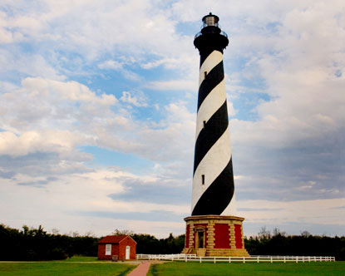
Location:
Cape Hatteras Lighthouse is located off the Outer Banks in Buxton on the coast of North Carolina.

Interesting Facts:
It is the tallest lighthouse in North America and is the tallest brick building ever moved. The lighthouse was moved in 1999 over 2900 feet to protect it from being too close to the ocean. It took 23 days to move it.

Activities:
The lighthouse is open to visitors during the summer months to climb the 248 steps to reach the top of the lighthouse.

The seashore near the lighthouse is an excellent place to explore different kinds of seashells.

Animals: whales, sharks, dolphins, sea turtles, and many other different kinds of fish

