Town of Beech Mountain
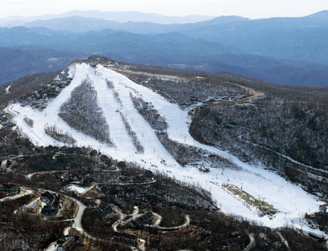
Location:
Beech Mountain is located in the Appalachian mountains of North Carolina.

Interesting Facts:
The town of Beech Mountain is located near the North Carolina and Tennessee state line.

The town of Beech Mountain has been around since the 1960’s. That’s more than 50 years!

Activities:
- Skiing and snowboarding at the Beech Mountain Ski Resort
- Sledding down a hill with a snow gum
- When it’s warm, some people walk or bike a 10 mile trail
- Waterfall hiking
- Golfing
- Fishing

Animals:
Owls, Red-tailed Hawk, Black bear, Beaver, Fox, Coyote, Bats, Corn Snake, Rattlesnakes, Snapping Turtle, Frogs, Salamanders

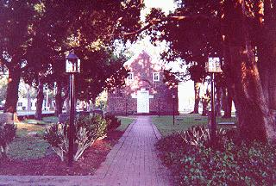
City of Bath

Location:
The City of Bath is located in the Coastal Plains of North Carolina, just north of the Pamlico River.

Interesting Facts:
Bath was the first town in North Carolina.

The first public library was established in Bath.

There is only one elementary school, Bath Elementary.

Activities:
- Fishing, canoeing and boating
- Wakeboarding and water skiing
- Visit historical sights that are more than 100 years old
- Ride the ferry that takes you to a state park

Animals:
Bald Eagle, American Alligator, Loggerhead Sea Turtles, Sea Gulls, Arctic Turns, Raccoons, Pelicans, Deer, Osprey

