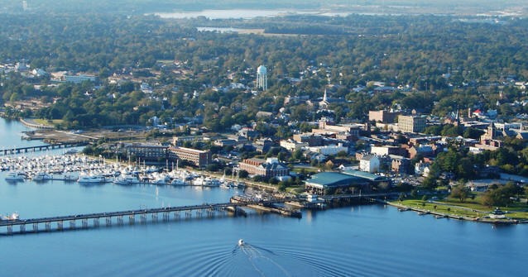
New Bern
Location:
New Bern, NC is located in Craven County on the coast of North Carolina.
Interesting Facts:
New Bern was settled by Swiss and German adventurers, and they named the city for the first animal they found. It was a bear. “Bern” was the Germanic word for bear! New Bern is the second oldest town in North Carolina! New Bern is home to the First State Capital of North Carolina, Tryon Palace. This pace was also the first city to celebrate George Washington’s birthday. Pepsi was invented and first served in New Bern by Caleb Bradham.
Activities:

- Go to parks
- Take tours
  - Tryon Palace
  - Fireman’s Museum
  - Birthplace of Pepsi
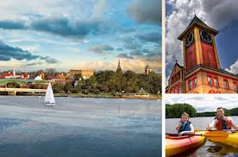
  - Bank of the Arts
  - Croatan National Forest
  - Christ Episcopal Church
- Golf
- Fish
- Tugboat Cruise
- Theatre
- Boating
- Biking
- Shopping
- See the Bear Town Bears across town

Animals:
There are many animals to see in New Bern, such as pelicans, alligators, sea turtles, herons, egrets, deer, raccoons, osprey, loggerhead turtles, and snow geese.

