Name: ___________________
One Way to be Healthy

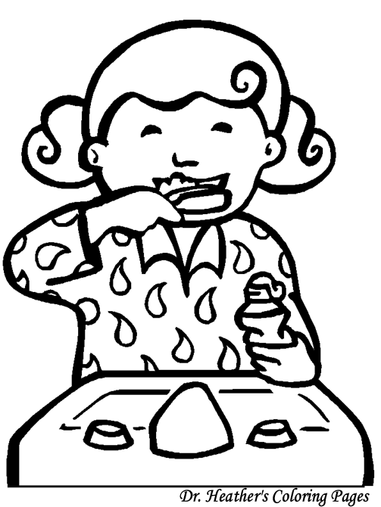
It is important to be healthy. One way to be healthy is to brush your teeth. You should brush your teeth everyday in the morning and at night. To brush your teeth, you need a toothbrush and toothpaste. It is important to brush your teeth because it keeps them clean and smell good. You also use them for eating and eating is something you will do your whole life! Make sure to always brush your teeth!
- Is the story fiction or non-fiction?
The story is _____________________
because ________________________
______________________________________________________________.
- What is this story mostly about?
This story is mostly about __________
______________________________.
- Using the story, why is it important to brush your teeth?
It is important to brush your teeth because _________________________
______________________________________________________________.
- Using the story, when should you brush your teeth?
You should brush your teeth at ________
_______________________________.

