[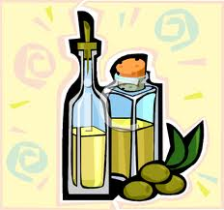](http://www.google.com/imgres?imgurl=http://www.clipartpal.com/_thumbs/bottles_food_191993_tnb.png&imgrefurl=http://www.clipartpal.com/clipart/food/condiments_191993.html&usg=__ISwVE8np95bgLpd_lKeFlb1aFxg=&h=327&w=350&sz=54&hl=en&start=0&zoom=1&tbnid=h3bc3JJ8McX5EM:&tbnh=145&tbnw=155&prev=/images?q=cooking+oil+clip+art&um=1&hl=en&rlz=1R2TSNA_enUS397&biw=1345&bih=532&tbs=isch:1&um=1&itbs=1&iact=hc&vpx=1087&vpy=173&dur=1965&hovh=217&hovw=232&tx=160&ty=124&ei=0PfZTOeDDIL88Aaw_OTzCA&oei=rffZTIqZBYG78gbnu7mqCQ&esq=5&page=1&ndsp=16&ved=1t:429,r:7,s:0)[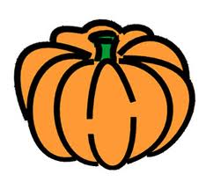](http://www.google.com/imgres?imgurl=http://www.pumpkin-clipart.com/pumpkin_clip_art_01.jpg&imgrefurl=http://www.pumpkin-clipart.com/&usg=__xnR2gDaWRhilJfQwCoUQWzawLjk=&h=289&w=315&sz=32&hl=en&start=0&zoom=1&tbnid=VJ6X7PpVk1WrcM:&tbnh=111&tbnw=122&prev=/images?q=pumpkin+clip+art&um=1&hl=en&sa=N&rlz=1R2TSNA_enUS397&biw=1345&bih=532&tbs=isch:1&um=1&itbs=1&iact=hc&vpx=110&vpy=90&dur=624&hovh=215&hovw=234&tx=127&ty=118&ei=XPfZTJ7PAsT58Abt8KGgCQ&oei=XPfZTJ7PAsT58Abt8KGgCQ&esq=1&page=1&ndsp=27&ved=1t:429,r:0,s:0)[](http://www.google.com/imgres?imgurl=http://www.clipartpal.com/_thumbs/bottles_food_191993_tnb.png&imgrefurl=http://www.clipartpal.com/clipart/food/condiments_191993.html&usg=__ISwVE8np95bgLpd_lKeFlb1aFxg=&h=327&w=350&sz=54&hl=en&start=0&zoom=1&tbnid=h3bc3JJ8McX5EM:&tbnh=145&tbnw=155&prev=/images?q=cooking+oil+clip+art&um=1&hl=en&rlz=1R2TSNA_enUS397&biw=1345&bih=532&tbs=isch:1&um=1&itbs=1&iact=hc&vpx=1087&vpy=173&dur=1965&hovh=217&hovw=232&tx=160&ty=124&ei=0PfZTOeDDIL88Aaw_OTzCA&oei=rffZTIqZBYG78gbnu7mqCQ&esq=5&page=1&ndsp=16&ved=1t:429,r:7,s:0)