Read to Someone/Vocabulary Station
Day 1: 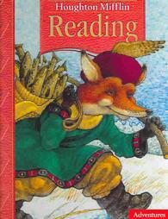
- You and your partner get the above textbook. Turn to page __________.
- You and your partner take a picture walk through the story and talk about what is happening on each page.
- Did you talk about the….
- Characters
- Setting
- Problem
- Solution
- Make a prediction about what you think will happen and write it in your RRJ.

Day 2:
- You and your partner get the above textbook. Turn to page __________.
- Read the prediction you made in your RRJ aloud to your partner.
- Begin reading the story with your partner aloud. Take turns reading and talking about the story.
- After reading the story answer questions 1, 3, 5 on page _______ in your RRJ.
- Put the heading : Dragon Questions page ____
- 1. Dragon plans to _____________________ when he can’t fit in his car. After that, _____________________________________
- 3. I think Dragon did not stop eating until all the food was gone ___________________________
- 5. I think the silliest parts of the story are ________________________________________ because_________________________________

Day 3: Vocabulary
- Get your vocabulary sheet and go back into the story on page __________ in your textbook.
- You and your partner discuss the words and what they mean now that you have finished the story. Write a sentence using each of your words.

