Read a story. List the characters and the setting.  Characters are who the story is about and the setting is where the story takes place. | Find adjectives in a story you’ve read and list them.  Adjectives are words that describe a noun. Example: The silly dragon in the story was very courageous. | Create a main idea web and include the main event that took place in the story and provide supporting details. 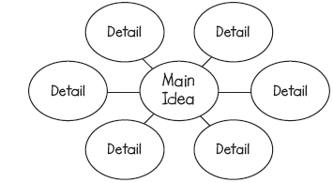 | Compare how the characters in the story act or feel using a Venn diagram.  A Venn diagram compares and contrasts two things.  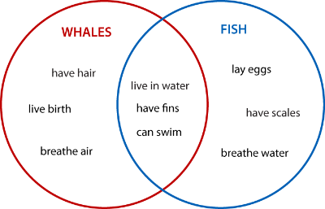 | Write down some questions you are wondering about your book: WHO, WHAT, WHERE, WHEN, WHY, HOW, COULD, SHOULD and CAN.
Write a different ending to your book. | What did you visualize while reading? Draw 3 detailed pictures of your mental images. Include captions. | Reading  Homework | What if your book took place in a different setting? How would it change the events of the story? | Did the character(s) learn a lesson in the story? What was it?
Create a comic strip summarizing what you have read. Make sure to include dialogue. | Write down some words that you have read and infer what they mean. What evidence did you use from the text to find the meaning? | If you were the author, what’s one thing you would change about the book and why? | If you wrote a sequel to this book, what title would you give it and why? | Pick a character trait to describe your character. What details support this?
Write a review of your book and pretend that you are writing a review for the local newspaper. | Retell a story you have read. Use the words first, next, then and last. | Make predictions about your book BEFORE, DURING< and AFTER reading. | Interview a character from your book. Include 5 questions and answers. | Describe how the character’s feelings changed throughout the story from the beginning to the end of the story.
*Choose a book of your choice and choose 1 option each night. Record in your homework journal. You should have 4 activities per week.
*HW Journals are due every Monday and they are returned to the students on Tuesday.
* Allow your child to choose a choice from the Tic Tac Toe that is at the student’s comfort level. They may challenge themselves if they like.

