Describe the setting of the story using 3 complete sentences or more.  The setting was _____.  I know this because I saw/I read ______. | Find adverbs in a story you’ve read and list them.  Adverbs are words that describe a verb (an action or something you do)  . Example: The silly dragon in the story quickly flew above the town. | Read a non-fiction book. Create a main idea web and include the main idea and provide supporting details. 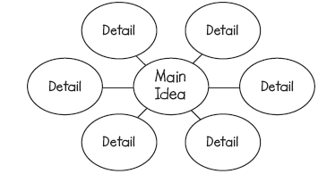 | Compare how the characters in the story act or feel using a Venn diagram (not what they look like). You can also compare what they do in the story.  A Venn diagram compares and contrasts two things.  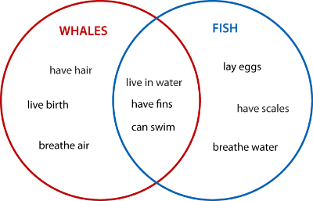 | Describe the problem of the story using 3 complete sentences or more.  The problem in the story was ______.  I know this because I saw/I read _______.
Write a different ending to your book. Use 5 sentences and include the characters talking or saying something to each other (dialogue). | Stop and check. Read a couple of pages, stop and write a sentence or two about what happened. Repeat 3 times. | Reading  Homework | Write about the solution to your book. Give 3 pieces of evidence.  The solution was _____. I know this because I read/I saw _____. | Did the character(s) learn a lesson in the story? What was it?  Give 3 pieces of evidence to support your statement.
Create a comic strip summarizing what you have read. Make sure to include dialogue. | Write down the theme and message of your fiction story. Tell 3 pieces of evidence that support your idea. | Choose a fiction or non-fiction book. Write down some examples of the cause and the effect.  Example. The animals are disappearing and becoming endangered because of all of the pollution in the air and water. | 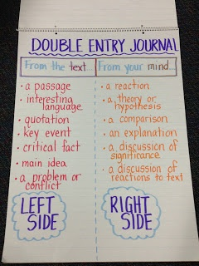Use this as an example to show how you thought about a part of the text. | Pick one character to tell about. Give 3 pieces of evidence about what they did/how they felt/how they acted.  Charlotte was a very smart spider because I read that she spelled a lot of smart words. She was a good friend to Wilbur because I read she helped him stay safe from being eaten. She was very brave because I read that she didn’t care what the farmers and other animals thought about her trying to save Wilbur.
Create a magazine article for one of your characters. Write down information you know about them (their favorites/what they like/information about them or their friends/family) or if you don’t know, infer what you think they may like. | Retell a story you have read. Use the words first, next, then and last. You can also use other transition words you have learned. | Read a non-fiction book. Create an FQR chart with 3 columns. Facts - Question (you have about the fact) - Response (what is the answer to your question, if no answer, what do you think it could be). | Read a non-fiction book and give examples of what you learned from the different text features:  caption …..  index …..  bolded word …...  Heading …..  Table of Contents ….  Glossary ….  Diagram/Map/Graph …. | Describe how the character’s feelings changed throughout the story from the beginning to the end of the story. Remember to tell why. Sam felt _____ because I saw/I read _____.
*Choose a book of your choice and choose 1 option each night (students may use one book per week and do 4 sdifferent homework activities with one book.) Record in your homework journal. You should have 4 activities per week. Please do not forget to record your books in your reading log.
*HW Journals are due every Monday and they are returned to the students on Tuesday.
* Allow your child to choose a choice from the Tic Tac Toe that is at the student’s comfort level. They may challenge themselves if they like.

