Book Club!
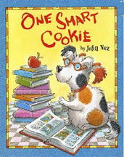
Name: __________
Write down all the “ing”, “ed”, and “y” words you can find in your book:
ing ed

Y Words:

Predictions!
Before Reading | During Reading | After Reading
What do you read as a reader?
Things I Read:

Retell the story using this flowchart:
First,

Then,

Next,

Last,

Draw and describe how Duffy was feeling in the beginning of the book and in the end of the book.
Ending:
Beginning:

What questions would you ask cookie if you were a reporter?
1)

2)

3)

Write an article that celebrates cookie! Write at least 1 paragraph with a main sentence, 3 details, and a closing sentence.
Main Sentence:
__________________________________________________________________________________________________________________

Detail 1:
____________________________________________________________________________

Detail 2:
____________________________________________________________________________

Detail 3:
____________________________________________________________________________

Closing Sentence:
____________________________________________________________________________

