Write your spelling words in ABC order | Make your words using newspaper or magazine clippings with 5 out of your 10 words. | Write your spelling words and trace two colors around them. | Write each of your spelling words. Next to each word, write a rhyming word. Your rhyming words can be nonsense words, but make them follow the same spelling pattern.  For example  Spill- Fill  Rich- lich  Thin-Fin | Write your spelling words and circle all the vowels or your word family.  For example,  Word family  at  Cat  Bat  Chat  Short I vowel  Spill  Rich  thin
Do a speed sort with your words, letter sound, blend/digraph, word or word family. | Write new words with the same letter sound, word family, or digraph/blend feature next to your picture or words. | Spelling  Homework | Have someone scramble your spelling words. You unscramble them.  glfa=flag  lilsp=spill | Write the words with bubble letters.  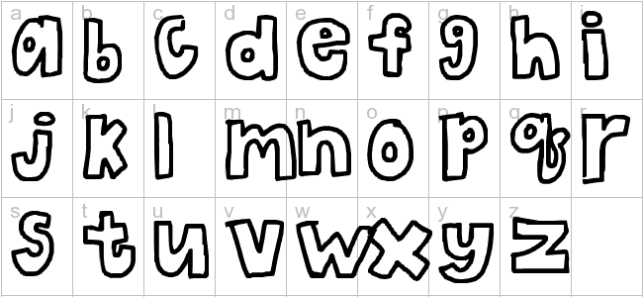
Write your words with rainbow spelling, change colors with each letter. | Have someone give you a pretend test. | Hide your words in a letter trail/crossword puzzle. Circle each word. | Write a silly sentence using each spelling word. Underline the spelling word. | Write your words and circle all of the vowels.  Vowels: a,e,i,o,u,y,
Write your spelling words inside 3D shapes. | Draw a picture of a big flower. Write each of your spelling words/letter sounds on one of the petals or on a leaf. | Write a definition for each of your spelling words | Choose 5 words and make a riddle about your words. | Trace around a cookie cutter in your journal. Completely fill up the inside of the shape with your words.
*Choose 10 different words each night. Record in your homework journal. You should have 4 activities per week. Please make sure your child is practicing the sort as students will be assessed on 10 words and they will be given 1pt for the correct sort of the word feature and 1pt for the correct spelling.
*HW Journals are due every Monday and they are returned to the students on Tuesday.
* Allow your child to choose a choice from the Tic Tac Toe that is at the student’s comfort level. They may challenge themselves if they like.

