Type 10 of your spelling words in a word doc on the computer and print them out. | Spell your 5-10 words with foods like pasta or beans. Write down the words you make. | Write 10 of your spelling words with dotted letters. Use 2 colors. | Draw 10 pictures to match 10 of your spelling words. Have a parent/sibling/friend match your words and pictures.  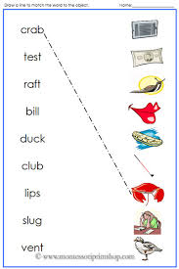 | Write your spelling words and underline all the consonants or your word family.  For example,  Word family:  at  Cat  Bat  Chat  Consonants:  Spill  Rich  thin
Do a speed sort with your words, letter sound, blend/digraph, word or word family. | Write the sorts at the top of the page. Come up with 5 new words that match the sorts, but are not already on your list. | Spelling  Homework | Write a rhyming poem with 5-10 of your words. | Write the words with striped or zig zag patterned bubble letters.  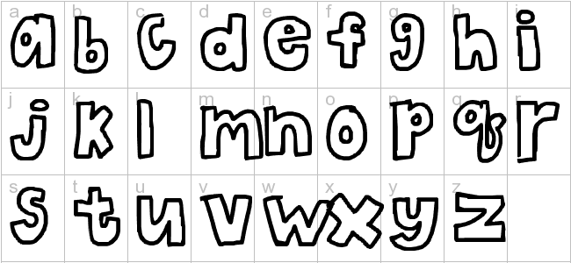
Write a mystery story using 5-10 of your words. | Have someone give you a pretend test. | Create a mystery code for an alphabet. Use the code to spell 5-10 of your words. | Write a silly sentence using each spelling word. Underline the spelling word. | Write your words and circle all of the blends or digraphs (2 letters together to make 1 sound).  ch, sh, th, wh, bl, fl, etc.
Write 5-10 of your spelling words and add up the amount/worth of each word.  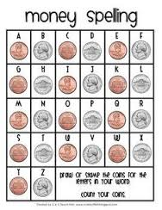 | Draw a setting (beach, jungle, forest, park) with 5 labeled details/objects. Hide 10 of your words inside. | Find a synonym (same) or antonym (opposite) word to go with 5-10 of your spelling words. | Make alliteration sentences using your word:  Sam shot silly seeds south of the sea. | Create a silly story using 5-10 of your spelling words.
*Choose 10 different words each night. Record in your homework journal. You should have 4 activities per week. Please make sure your child is practicing the sort as students will be assessed on 10 words and they will be given 1pt for the correct sort of the word feature and 1pt for the correct spelling.
*HW Journals are due every Monday and they are returned to the students on Tuesday.
* Allow your child to choose a choice from the Tic Tac Toe that is at the student’s comfort level. They may challenge themselves if they like.

