Book Club!
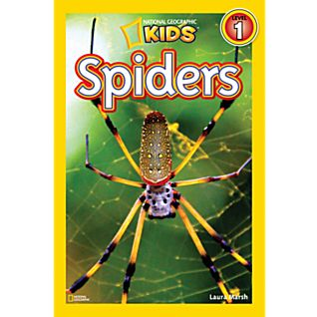
Name: _______________

Draw the different habitats of spiders:
(Where do they live?)

Draw, color, and label your favorite spider (Include Abdomen, Head, Legs, eyes):

Draw and label the 4 different types of webs:

Fact or Fiction:
Record your own facts, or fictions, on the cards below:

Page 18:
Write a paragraph about spiders spinning silk. Remember to include the main idea, 3 details, and a closing sentence.

List two ways a spider can be helpful:
1)

2)

Create your own Clue for Super Spiders!
a _________________
Best
_____________
__________________
__________________
a _________________
Best
_____________
__________________
__________________
a _________________
Best
_____________
__________________
__________________
a _________________
Best
_____________
__________________
__________________

