Spirit Day Ballot
___ Dance Party Day | 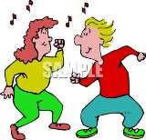
___ Ice Cream Party Day | 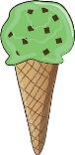
___ Costume Day | 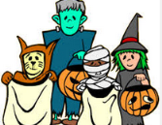
___ Face Painting Day | 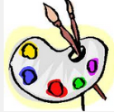  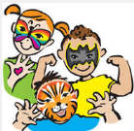
___ Electronics Day

___ Stuffed Animal Day | 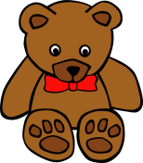
___ Crazy Sock Day | 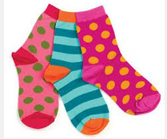
Spirit Day Ballot
___ Dance Party Day

___ Ice Cream Party Day

___ Costume Day

___ Face Painting Day

___ Electronics Day

___ Stuffed Animal Day
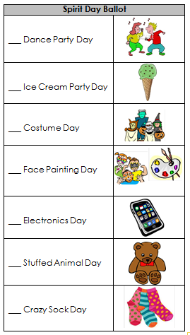
___ Crazy Sock Day

