Name: _______________
Pumpkin Problems
- Jeffrey had 13 carrot sticks. He ate 5 of them and gave 6 away. How many does he have left to eat?

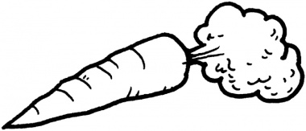

- Nick’s mom told him he had to eat all of his green beans if he wanted dessert. He ate 6 of them and has 6 more on his plate. How many green beans does he have to eat to get dessert?

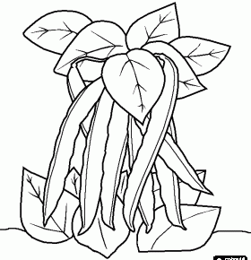

- Shannon boiled 16 eggs. She needs 7 more to make enough deviled eggs for dinner. How many eggs did she use in all?

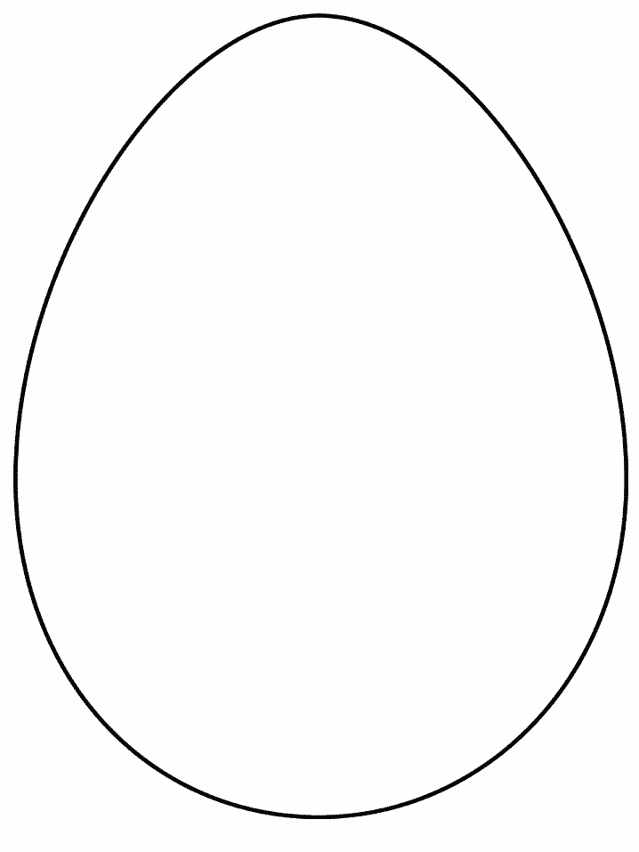

***BONUS: Create your own story problem about healthy foods on the back.

