History of Stars and Constellations
Long ago, before GPS, sailors used stars to help them guide their ships while sailing on the ocean. The study of stars has been around for hundreds of years and has played a key role in navigation. With the invention of the telescope, scientists were now able to get a closer view of what stars really look like. They discovered that a star is a gigantic, glowing ball of plasma (or really hot gas).

Ancient cultures saw patterns in the sky at night that resembled people, animals or common objects. These figures came to be known as constellations. Constellations are imaginary things. (There aren’t really animals or people in space.) The reason why constellations are used is to help us tell which stars are which. They help by breaking up the sky into smaller pieces.

Big Dipper
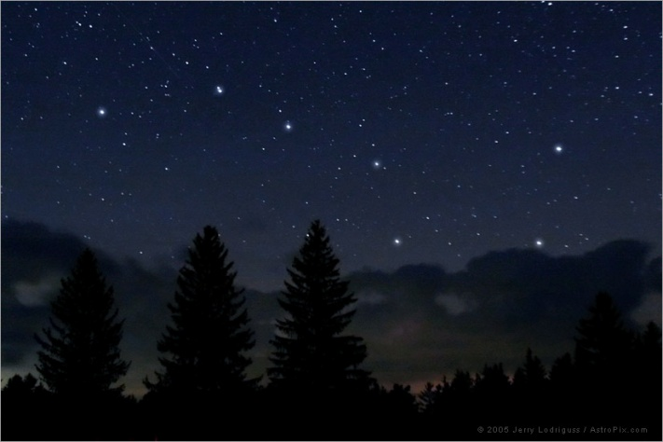
The Big Dipper lies low in the north. This constellation helped sailors at sea sail north. At the end of the bowl of the Big Dipper is a bright star. This is called the North Star and it “points” north. It is a circumpolar constellation, which means it is always above the horizon for viewers to see it. The Big Dipper is part of the larger constellation Ursa Major and is made up of 7 stars.

The very best time to look at the Big Dipper is in the middle of the summer. On these nights, there are usually no clouds.

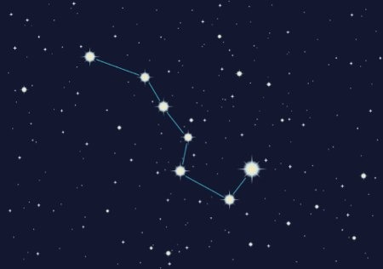
A little over 100 years ago, African-Americans that were being held as slaves in the United States used the Big Dipper. Most of the slaves lived in the south so they used the North Star of the Big Dipper to point them in the direction of north. They called the Big Dipper the Drinking Gourd.

In other countries, the Big Dipper is referred to as the Plough, the Saucepan, the Great Wagon, and the Big Bear.

Little Dipper

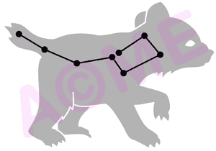
The Little Dipper, is part of the constellation of Ursa Minor. Ursa Minor is also known as Little Bear.

In ancient times, the Little Dipper formed the wings of the constellation Draco the Dragon. This changed when a scientist names Thales discovered that the wings of the dragon could be “clipped” and form a new constellation. This allowed sailors to use the North Star, found at the end of the Little Dipper, while sailing at sea.

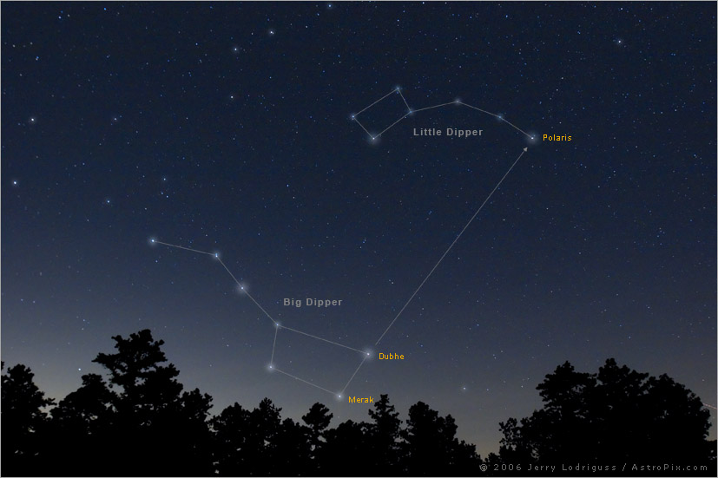
Like the Big Dipper, the Little Dipper is best seen during the summer month of June and is made up of 7 stars.

Cassiopeia

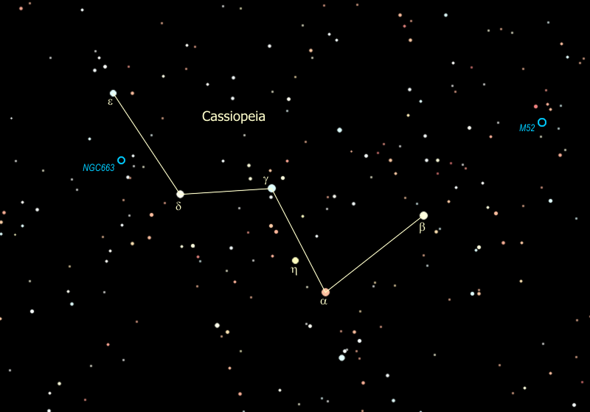
The constellation Cassiopeia has a very distinct shape. It looks like a “W” or “M” in the sky, depending on where it is.

Cassiopeia is a northern part of the world and can be viewed all year long. It is close to several clusters, or groups, of stars. There are also a few nebulas close to Cassiopeia. A nebula is a large cloud of dust in outer space.

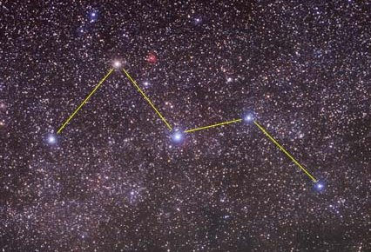
The name Cassiopeia comes from a Greek legend, or story. Cassiopeia was the wife of a king. She was very beautiful but mean. The story tells how her pride caused great upset to her kingdom.

Orion
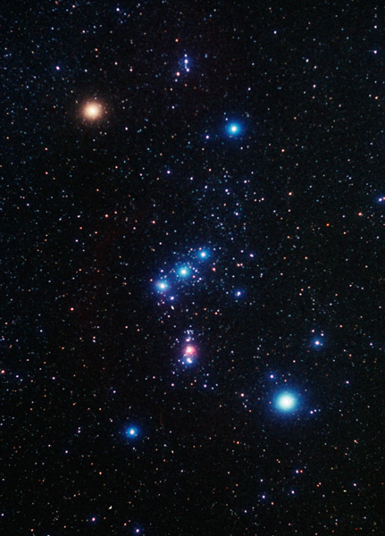
Orion is one of the largest constellations in the sky and is also one of the easiest to find. It is only visible in the early morning and the best months to see it is from August through December. If you live in the northern half of the world, you’ll find it to the south. If you live in the southern half of the world, you’ll see it towards the north. Everyone can see this constellation!

Orion is also home to one of the most beautiful objects in the night sky, the Orion Nebula. A Nebula is a cloud of dust in outer space.

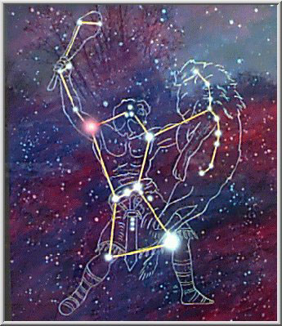
The name Orion comes from a story from the country of Greece. Orion was the master of the skies. His hunting dog Sirius never leaves his side. In the picture to the left, you can see Orion hunting a lion. For these reasons Orion has the nickname “Hunter.”

Capricornus
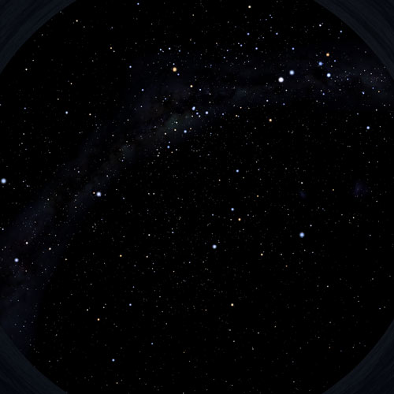
Capricornus, is often called Capricorn, is located in the southern sky. This means that if you live in the northern part of the world, you will have to look towards the south to see it. It is easiest to see Capricornus in the month of September.

The Capricornus constellation is the 40th largest constellation in the sky. The name Capricornus means “sea goat” in Latin.

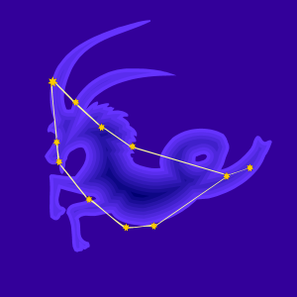
The name comes from a Greek myth, or story. In the story Capricornus and his friends were enjoying a picnic when all of a sudden a monster attacked! He quickly jumped into the magical river. Since his lower body was in the water, it turned into a fish while his upper body remained a goat.

