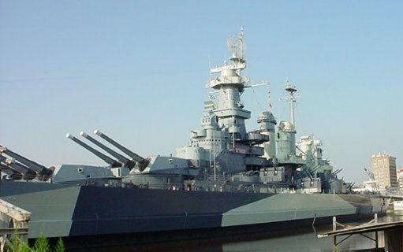
The Battleship
Location: The USS Battleship is found in the coastal region. It is located in the city, Wilmington, North Carolina, on the Cape Fear River. The city of Wilmington is in New Hanover County.

Interesting Facts: The Battleship was used in World War II. The ship has been docked in Wilmington since 1961 for tourists to visit. The ship is about 730 inches long. It could hold more than 2,000 people when in battle. The ship was like a floating city to meet the crew’s needs. The kitchen on the ship is called the “galley.”

Activities:
- Tour the ship every day of the year! It is a memorial.
- Schools can tour the Battleship as a field trip.
- Hidden Battleship tours show tourists to parts of the ship that were never rebuilt or restored. You must be 12 or older to explore the more secret areas of the ship.
- Ghost Ship takes place around Halloween in October when the Battleship tour becomes “haunted.”
- Easter Egg Hunt Carnival takes place around Easter and allows visitors to enjoy egg hunts and games every 20 minutes.
- You can schedule events to take place on the Battleship including weddings, birthday parties, or festivals.

Animals Found Near the Battleship Area: Herrings, sea turtles, striped bass, alligators, woodpeckers, minnows, pelicans

