Tweetsie Railroad
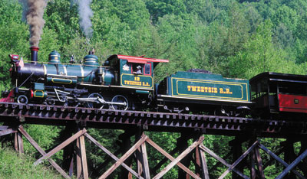
Located:
Tweetsie Railraod is located in the mountains of North Carolina between the city of Boone and Blowing Rock.

Interesting Facts:
The traian was built in 1917 and was built to carry people and freight from Appalachian Mountains to Boone, North Carolina.
Tweetsie Raliroad was one of the first theme parks to open. The train made its first run on the tracks in 1957. Tweetsie Railroad became a popular tourist attraction, and turned into one of the nation's first theme parks. A train robbery and Indian attack show were added to the train ride, playing off the Wild West theme that was very popular at the time on television and movies.

Activities:
- Ride on the steam engine train
- Go panning for gold
- Go gem mining
- Ride a charlift and look at the mountains
- Visit the Deer Park Zoo

Animals that can be found:
- Brown bears, deer, wolves, beavers, squirrels, coyotes, bobcats, moose, fox, raccoons

