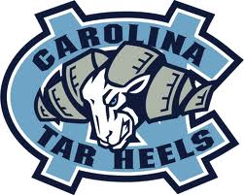
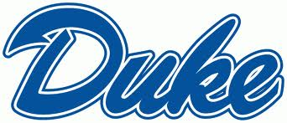
Universities
Piedmont
Interesting Facts:
UNC Chapel Hill: This school started in 1795. The school's sports teams are known as "Tar Heels" and their mascot is a ram. The student radio station WXYC provided the world's first internet radio broadcast. In 1952, North Carolina opened its own hospital up, UNC Health Care. It now treats cancer. It is one of the oldest public university in the United States.
NCSU: This school started in 1887. It is the largest university in the state. NC State has almost 8,000 employees, nearly 35,000 students, NC State is known for agriculture, life sciences, design, engineering, textiles, and veterinary medicine. NC State is known as the Wolfpack’s and their mascots are Mr. and Ms. Wuf.
Duke University: The school was first in the city of Trinity in 1838, and the school moved to Durham in 1892. Duke's teams—known as the Blue Devils—have won 12 team national championships, including 4 by its men's basketball team. Duke's teams have won twelve NCAA team national championships. Duke is a private research university. Duke University Library System is one of the ten largest private research university library systems in the U.S. There are more than 6 million books!
East Carolina University: This school started on March 8, 1907. ECU's sports teams are nicknamed the Pirates, At this school you can learn to be a teacher, a nurse, a musician, a business person, an actor, or a doctor.
North Carolina A & T University: Men’s sports are: Baseball, basketball, cross country (running), football, outdoor track and field. Women’s Sports are: Basketball, bowling, cross country, softball, swimming, tennis, volleyball, outdoor track and field. "Aggie" the bulldog is the mascot for North Carolina A&T.
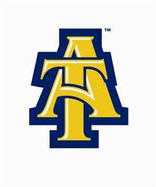
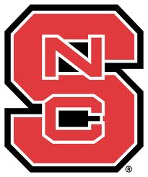

Activities:
UNC
You can visit the Morehead Planetarium to see the stars. You can go shopping on Franklin Street. You can see a show or play at Playmakers Theatre You can visit a historical landmark, which is the Old Well which provided water for the university a long time ago.

NCSU

Krispy Kreme Challenge

Run 2 miles to Krispy Kreme, eat twelve glazed doughnuts, then run back to the Bell Tower within one hour.

Shack-A-Thon
The Shack-A-Thon, NCSU students build shacks that the students live, sleep, and study in for an entire week. Each group raises money by collecting from people walking through the brickyard. This money goes toward funding a house through Habitat for Humanity of Wake County.
DUKE:
Visit the Sarah P. Duke Gardens. Look at the gothic buildings. See a sports game at Cameron Indoor Stadium. Visit the Lemur Center to see Lemur monkeys in the world’s largest sanctuary. Go hiking in the Duke Forest.
East Carolina University (ECU)
Barefoot on the Mall is held every spring, where you can hear musicians from all genres for an all–day concert and features various games, rides, and food.
Freeboot Fridays are held every Friday. It offers free concerts, free food, and children’s activities.
The Billy Taylor Jazz Festival gathers musicians from all parts of the world.
Purple & Gold Pigskin Pigout Party, held each spring. This event features a carnival, various cooking contests including a pork barbecue team cookoff, a car show, a celebrity golf tournament, a parade, free live entertainment, and the annual Purple & Gold spring football game.
Animals:
Some of the animals that live here are: Dragonflies, Bullfrogs, Jackrabbits, Fiery Black Shiner Fish, Creek Chub fish, Hawk, Barred Owl, Racoons, White-Tailed Deer, Beavers, and Wild Turkeys.

