Monday, December 16th, 2013
Theme: Holiday Winter Fun!
Math Monday!
Arrival/Morning Meeting 8:00-8:30/8:40
Snowman Day!!!’ Students play Snowman Slap! Sight word game!
Calendar/Daily 5 Math 8:40-9:30
Math Lesson:

Mathematics Math Expressions Lesson

Grade 1 Quarter 2 Day 62

Common Core State Standard(s)
1.NBT.2 Understand that the two digits of a
two-digit number represent amounts of tens
and ones. Understand the following as
special cases:
a. 10 can be thought of as a bundle of ten
ones—called a “ten”
b. The numbers from 11 to 19 are composed
of a ten and one, two, three, four, five, six,
seven, eight, or nine ones.
c. The numbers 10, 20, 30, 40, 50, 60, 70, 80,
90 refer to one, two, three, four, five, six, seven,
eight, or nine tens (and 0 ones).

Vocabulary

cents
coin
nickel
dime strip
dime
penny

Assessment
- As children are working, ask questions such as, “Why are the dimes counted first, and then the pennies?”
“Suppose you have 12 cents, what coins
could you have?”

Math Expressions Lesson

Unit 5 Lesson 1: Explore Dimes and Pennies

Activity 1
1. Introduce the Dime Strip to the class (SAB pg. 155). Invite
children to share what they observe about the dime strips
and anything they already know about dimes.
2. Show 5 Dime Strips (penny-sides up) and 3 loose pennies.
Have the class count the number of cents aloud, “freezing”
after the 5 tens and then shifting to the ones.
3. Next, turn over the 5 dime strips to show the dime sides. Show
a real dime and explain that a dime is worth 10 pennies, or 10
cents. Make sure children understand that the value is the
same for the dime side or the penny side of the strip.
4. Have children find the value of the money again and continue
to use the freeze and shift method to practice (freeze after the
tens and then shift to the pennies).
5. Now, show a real dime and a real penny. Ask children to
compare the appearance of the two coins. Discuss why dimes
are worth more even though they are smaller than pennies.
Example questions: “How are these two coins alike? How are
they different? The dime is smaller, but is it worth more or
less than the penny?”
6. Have children work in small groups at their desks, using the
dime strips and pennies. Each group should have 8 dime strips
and loose pennies. Have groups work together to arrange and
count the same number of dime strips and pennies that you
show.
7. Example: “Let’s show 7 dimes and 4 pennies. How many
cents do we have? Let’s count and see: 10, 20, 30, 40, 50, 60,
70, FREEZE! 71, 72, 73, 74.”
8. Make several more coin amounts and have groups show the
same amount at their desks and count the total number of
cents.
Activity 2
1. Using SAB page 157, children ring the correct number of
dimes and pennies to show each amount. Explain that in
Exercises 3 and 4, children should count the dimes and
pennies, and then write the total amount.

How to Make a Snowman – Read/Watch the biggest, best, snowman ever! Students will complete a 4 square listing the 4 steps to making a snowman using the words First, Then, Next, and Last. They will complete their writing with snowman art. See pic below:
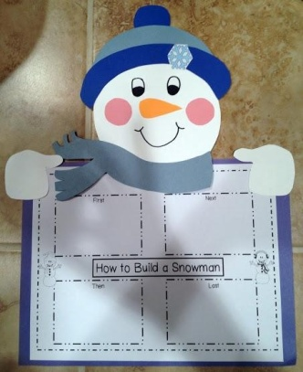
Specials 9:35-10:20 – Chinese Mrs. Liu
Snack 10:20-10:40 Read aloud Snowmen At Night! – Snowman donuts and milk!
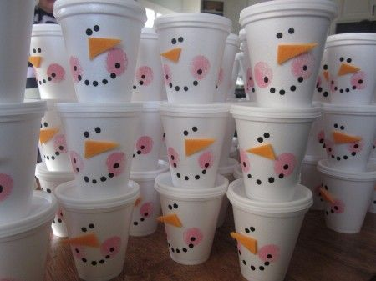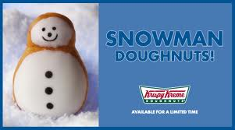
Daily 5 Literacy 10:40-12:30
Spelling Test Unit 11

Stations:
***Ms. Smith will be monitoring students at their stations by walking around and ensuring students are at the correct station doing the appropriate task. Refer to literacy station description print out for what students should be doing at each station. Our goal this quarter is at least 4 sentences.
Mrs. C will call reading groups to the back table. Groups 1 and 2.
Writing:
Snowmen at Night – Students write a story about what their snowman would do at night. They will use their plan: See, Smell, Hear, Taste, Touch. Students will then begin to design their background to go with their snowman, but will need to draw 3 circles for their snowman first. When their background is complete, they can add loose glue and glue marshmallows and pretzels down for their snowman.
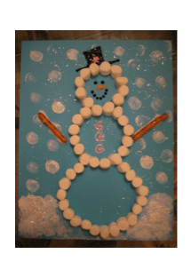

Lunch 12:35-1:05 Recess 1:10-1:40
Writing/Soc. Stud/Sci/STEAM 1:40-2:40
Finish Snowman Art!

SnowMan Games! Minute to win it!

Snowblower (toilet tubes and ping pong balls) – Choose a few students to use their tubes to blow in and blow the ping pong ball across the table and into the cup taped to the opposite side of the table.

Snowman Wrap Up (toilet paper and 3 black circles) – Choose 2 students to wrap and 1 student to be the snowman for each group. They wrap with toilet paper to make a white snowman, top it off with hat/gloves/scarves and 3 black paper buttons taped on.

Snow drop! (Cookies on face) – Use white fudge oreos . Choose a few students to race who can move the cookie from the top of their head to their chin the fastest using only their face muscles.

Snowflake race! Choose a couple of students to place a large snowflake on their head and race around the room (obstacle course) without dropping the snowflake.

Snowball Toss (Cotton balls!) – Students stand on one side of the table and try to toss as many snowballs into the cups on the other side in a minute.
Plus/Delta & Pack-Up 2:45
Carpool 2:50
Walkers 2:55
Bus 3:00-3:15 ish
YMCA 3:10

Tuesday, December 17th, 2013
Theme: Holidays Winter Fun!
Thinking Tuesday!
Arrival/Morning Meeting 8:00-8:30/8:40
Grinch Day!!!!
Calendar/Daily 5 Math 8:40-9:30
Math Lesson:

Mathematics Math Expressions Lesson

Grade 1 Quarter 2 Day 63

Common Core State Standard(s)
1.NBT.1 Count to 120, starting at any number less
than 120. In this range, read and write numerals
and represent a number of objects with a written
numeral.
1.NBT.2 Understand that the two digits of a
two-digit number represent amounts of tens and
ones. Understand the following as special cases:
a. 10 can be thought of as a bundle of ten
ones—called a “ten” b. The numbers from 11 to 19 are composed
of a ten and one, two, three, four, five, six,
seven, eight, or nine ones. c. The numbers 10, 20, 30, 40, 50, 60, 70, 80,
90 refer to one, two, three, four, five, six, seven,
eight, or nine tens (and 0 ones).

Materials Needed:

- Math Expressions Volume 1
  - TE pages 405-410
  - MathBoard materials
  - Demonstration Secret Code Cards 1-9
  - Real or play money

Assessment
- As children work on their Number Paths, be sure they understand how to group the ones into a stick of ten which equals a dime. Ask individual students the total, whether he or she made another dime, and how many more pennies until another dime is made.
Vocabulary
penny
nickel
dime
cent
dollar
total
coin

Math Expressions Lesson

Unit 5 Lesson 2: Group Pennies into Dimes

Activity 1
1. Write a 2-digit money amount on the board and draw dimes
and pennies to show the amount.
2. Have children draw these coins on their MathBoards and
remind them of the relative sizes of the two coins.
3. Write another 2-digit amount on the board and ask 2 or 3
volunteers to draw the amount on the board while others draw
at their seats. Repeat with different amounts.

Activity 2
1. Have the class play “One Hundred Pennies.” Remind children
this game is similar to “One Hundred Ants” except that the
numbers on the cards now represent pennies instead of ants.
2. Mix up the Demonstration Secret Code Cards 1-9 and place
them face down. Take one, show it to the class, and say, “You
earned __ cents.”
3. Starting at 1, children make that number of dots on the Number
Path and write the total. Explain that the class is trying to earn
100 pennies (1 dollar) to buy a tent.
4. Draw another card and have children add that number of dots,
starting where they left off. As they make the dots, children
should count on aloud from the previous number.
5. Children draw a stick through each new ten column and a dime
to the right of each new ten that is made. After counting, they
write the new total number of cents.
6. For each turn after the first one, you and the class will say the
following chant:
Class (giving the new total): __ pennies won’t buy a tent.
Teacher (giving the next number): You earned ___ more
cents.
7. As children play the game, ask them to anticipate whether they
will be able to make a dime. Reinforce ten-partners by asking
them how many pennies it will take to make another dime.
8. Play the game until children have “earned” 100 pennies and
remind children that they now have one dollar.

Mrs. C will be calling math groups to the back table.
Specials 9:35-10:20 – Chinese Mrs. Liu
Snack 10:20-10:40 Read aloud The Grinch Who Stole Christmas Listen to the Grinch song!– Make Grinch Punch!
Daily 5 Literacy 10:40-12:30
Read the poem Grinch Punch. Students write about how to make Grinch punch using the words first, then, next, and last. Compare data with the Grinch Punch Graph.

***Ms. Smith will be monitoring students at their stations by walking around and ensuring students are at the correct station doing the appropriate task. Refer to literacy station description print out for what students should be doing at each station. Our goal this quarter is at least 4 sentences.
Mrs. C will call reading groups to the back table. Groups 3 and 4.
Reader’s Workshop/SS.
Write about what adjectives you could use to describe the Grinch in the beginning of the story.
Decide what adjectives you could use to describe the grinch’s heart in the beginning.

Write similies for the Grinch: The Grinch was a ___as ___. His heart was as ___as ____.

Write how you would make the grinch grin.
Watch the Movie the Grinch!!!! As students are watching allow them to create the art to go with their writing:
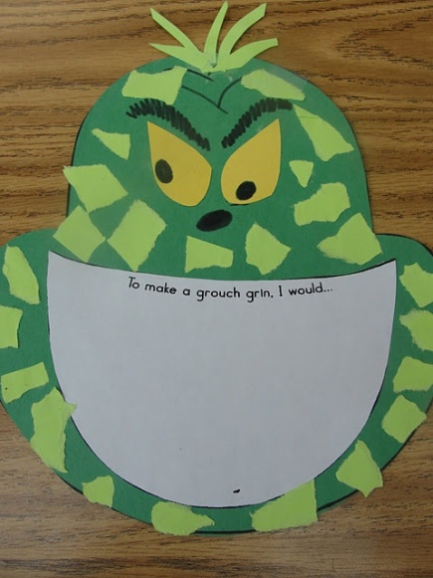

Lunch 12:35-1:05 Recess 1:10-1:40
Writing/Soc. Stud/Sci/STEAM 1:40-2:40
Movie!!! Make Grinch dust!!!
Plus/Delta & Pack-Up 2:45
Carpool 2:50
Walkers 2:55
Bus 3:00-3:15 ish
YMCA 3:10

Math for Wednesday if time:

Mathematics Math Expressions Lesson

Grade 1 Quarter 2 Day 65

Common Core State Standard(s)
1.NBT.1 Count to 120, starting at any number less
than 120. In this range, read and write numerals
and represent a number of objects with a written
numeral.
1.NBT.2 Understand that the two digits of a
two-digit number represent amounts of tens and
ones. Understand the following as special cases:
a. 10 can be thought of as a bundle of ten
ones—called a “ten” b. The numbers from 11 to 19 are composed
of a ten and one, two, three, four, five, six,
seven, eight, or nine ones. c. The numbers 10, 20, 30, 40, 50, 60, 70, 80,
90 refer to one, two, three, four, five, six, seven,
eight, or nine tens (and 0 ones).

Vocabulary
Hundred Grid
pattern
row
grid
sticks and circles

Assessment
- Ask questions such as: How do the numbers change as you move along each row in the Hundred Grid? How did you add ten on the Hundred Grid? How can you add ten without the Hundred Grid? How can you use the Grid to check a total when you add ten to a number?

Math Expressions Lesson

Unit 5 Lesson 6: Create a Hundred Grid
Activity 1
1. Ask children to turn their MathBoards to the side with the
10x10 Grid. Children should number all of the squares in
sequence, moving from top to bottom. Children will be writing
the number 1-100. Do the same on the Class MathBoard at the
front of the room.
2. When children have finished, read the numbers 1-100 aloud as
a class. The next activity will use these child-created Hundred
Grids.
Activity 2
1. Lead children in a discussion of patterns they see on the grids
they made. Let them make their own observations before
directing their attention to any pattern.
2. Be sure to ask/say the following statements: “A Hundred Grid
shows all the numbers from 1-100 in groups of ten. Where do
you see groups of ten?” “Look at each vertical column. Tell
me about the tens and ones. “ “Look at the horizontal column.
Tell me about the tens and ones.”
3. Guide children to realize that each number going across
increases by ten.
4. Next, circle the third row and have children draw sticks and
circles for each number, moving across the row. Make your
own on the class MathBoard as children are working.
5. Discuss the pattern and why it happens. Make a rectangle
around the seven squares below 3 and three squares 11, 12, and
13. The 10-partners 7 and 3 show why we get a new ten each
time. (A visual representation can be found on TE page 431).
6. Select several numbers on the grid and ask the class to try
adding a ten. Remind them to look at their own Hundred Grids
to help them find the answer. Each time draw the 10-partner
rectangles to see the ten added on. Example: “Find 47 on the
grid. Now add a ten.”
7. When children have caught on to the pattern, make this
exercise into a game, using the rhyme, “__ beetles on the floor.
Add ten more. ___.” As you say the number, write it on the
board and children respond with the total.
Example: “56 beetles on the floor. Add ten more. 66.”
8. Have children turn over their MathBoards and answer
questions without visual assistance. If you wish, invite a
student leader to continue the game.
Additional Teacher Notes:
- None Referenced

Wednesday, December 18th,2013
Theme: Holiday Winter Fun!
Word Study Wednesday!
MOVIE DAY!!!!
Arrival/Morning Meeting 8:00-8:30/8:40
If you take a mouse to the movies!
Calendar/Daily 5 Math 8:40-9:30
Read aloud: If you take a mouse to the movies
Make mice to fit in students’ pockets for the movie
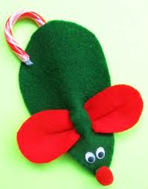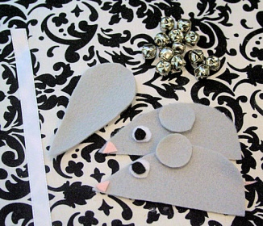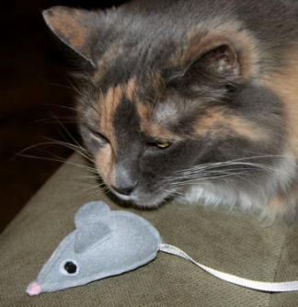
Popcorn snack before the movies!
Create an If/Then chart of events from the story.
Review: Put story events in order -
Write about the beginning/middle/end of the story and illustrate each part.
MOVIES!!!!
Lunch 12:35-1:05 Recess 1:10-1:40
Writing/Soc. Stud/Sci/STEAM 1:40-2:40
Class winter celebration!!!!
Plus/Delta & Pack-Up 2:45
Carpool 2:50
Walkers 2:55
Bus 3:00-3:15 ish
YMCA 3:10

Thursday, December 19th, 2013
Theme: Holiday Winter Fun!!!
Tweet Thursday!
Arrival/Morning Meeting 8:00-8:30/8:40
Reindeer Day!!! Make a reindeer hat!!!
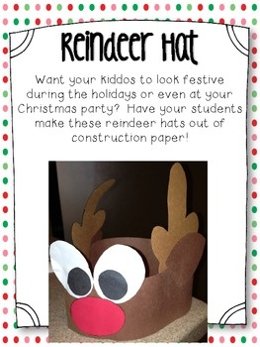
Winter Chorus Concert TBA ----
Calendar/Daily 5 Math 8:40-9:30

Mathematics Math Expressions Lesson

Grade 1 Quarter 2 Day 66

Common Core State Standard(s)
1.NBT.1 Count to 120, starting at any number less
than 120. In this range, read and write numerals
and represent a number of objects with a written
numeral.
1.NBT.2 Understand that the two digits of a
two-digit number represent amounts of tens and
ones. Understand the following as special cases:
a. 10 can be thought of as a bundle of ten
ones—called a “ten” b. The numbers from 11 to 19 are
composed of a ten and one, two, three, four, five, six,
seven, eight, or nine ones. c. The numbers 10, 20, 30,
40, 50, 60, 70, 80, 90 refer to one, two, three, four, five,
six, seven, eight, or nine tens (and 0 ones).

Assessment
- As students are working, observe their ability to move the correct direction and number of spaces when adding groups of ten. Observe the strategies students use to solve problems in Activity 2 (10 sticks and circles, mental math, etc.)
Vocabulary

add greatest
Hundred Grid across
sequence row
order pattern
least

Math Expressions Lesson

Unit 5 Lesson7: Explore the Hundred Grid
Activity 1
1. Have children turn to SAB page 167. Lead the class in reading
aloud the numbers 1-100 together, pointing to each number as
you go.
2. On the board write the ten-based sequences:
21, 31, 41, ___, ___, ___, ___
38, 48, 58, ___, ___, ___, ___
17, 27, 37, ___, ___, ___, ___
29, 39, 49, ___, ___, ___, ___
Lead children in reading the numbers in unison and then
continuing the pattern as far as they can.
3. Ask a few volunteers to make up their own pattern sequences,
having the leader give the first three numbers and the other
children join in and continue the number sequence.
4. Next, explain to children that they will now look for ones and
tens on the Hundred Grid (SAB page 167). Direct children to
ring numbers as follows:
Ring every number with 5 ones in red.
Ring every number with 7 tens in blue.
Ring every number with 2 ones in green.
Ring every number with 3 tens in orange.
When children have completed the task, ask them to share
their observations. Discuss why some numbers have more
than one ring around them. Encourage children to talk about
any patterns they noticed.
Activity 2
1. One at a time, write the following exercises on the board. Ask
children to explain how to use the Hundred Grid to find the
totals.
79+20=___ Where do you start to count? (79) Which way
will you go and why? (to the right; that is ten more spaces on
the grid) How many spaces do you move to add 20? (2) What
is the total? (99)
43+30= ____ 62+20=____ 23+10=___
28+50=____
2. Present similar exercises to the class, and ask children to figure
out how they could add tens without the grid. Invite some
volunteers to work at the board (draw sticks and circles to
solve).

Additional Teacher Notes:
- Have students select crayons prior to beginning Activity 1.

***Ms. Smith will be monitoring students
Reindeer Addends Art: Students will pick a number and write equations to match the sum/difference on the antlers.
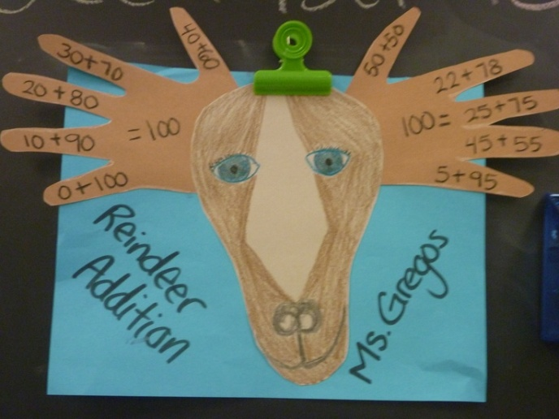
Specials 9:35-10:20 – Library Mrs. Headley? Chorus concert instead???
Snack 10:20-10:40 – Root Beer Float! And popcorn and water!!!!
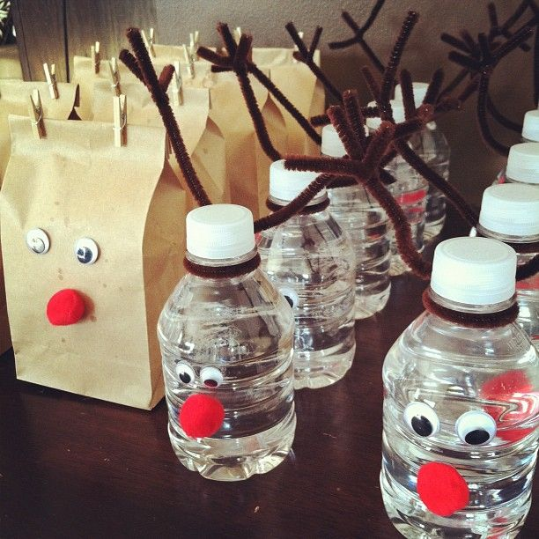
Daily 5 Literacy 10:40-12:30
Reindeer Art!
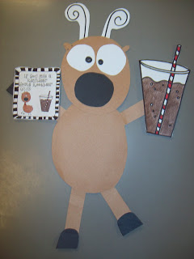
How to Make a Rootbeer Float! Students write the steps to making a rootbeer float using the words: First, Then, Next, and Last. Encourage students to add descriptive details in their sentence. If they finish their writing, they can begin to make their reindeer art.
Reader’s Workshop: Read the book MoostleToe – Write about the beginning, middle, and end and illustrate each part.

Watch Rudolph!!!
Lunch 12:35-1:05 Recess 1:10-1:40
Writing/Soc. Stud/Sci/STEAM 1:40-2:40
If you Give a Reindeer a Candy Cane! Students will write a sequel story to “If you take a mouse to the movies” They will write what will happen if you give a reindeer a candy cane. As students write, they will be called 1 at a time to glue their reindeer candy cane together and make their baggie of reindeer food :o)

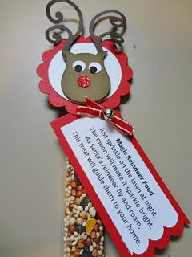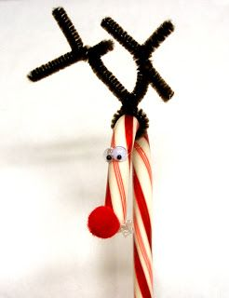
Plus/Delta & Pack-Up 2:45
Carpool 2:50
Walkers 2:55
Bus 3:00-3:15 ish
YMCA 3:10

Friday, December 20th, 2013
Theme: Holiday Winter Fun!!!
Fix It Friday! Royal Sentences
Arrival/Morning Meeting 8:00-8:30/8:40
Polar Express Day!!! Pass out tickets to board the polar express!
Calendar/Daily 5 Math 8:40-9:30

Assessment Day 67 ---
Read the book Polar Express: Retell the story using beginning, middle, and end.

Do you like marshmallows in your hot chocolate? Students go around the room and ask friends to complete their graph
Graphing and comparing student responses.

Marshmallow Math – Subtraction with marshmallows and hot chocolate (laminated recording sheets)
Specials 9:35-10:20 – Library Mrs. Headley
Pass out on backpacks – Polar Express bells!!!
Snack 10:20-10:40 – Hot Chocolate!
Write how to make hot chocolate using the words first, then, next, last

Daily 5 Literacy 10:40-12:30
Watch the movie – Polar Express
Students sip hot chocolate, Polar express puzzle! Try to make a train out of shapes.

Lunch 12:35-1:05 Recess 1:10-1:40
Writing/Soc. Stud/Sci/STEAM 1:40-2:40
Persuasive Writing: I should receive a ticket to ride the polar express because…
Students state a topic sentence, 3 reasons, and a closing sentence.

If time, students can choose a random classroom object, pick a name from a jar, and decorate a paper bag to put the item inside as a gift. Pass out gifts, and students write a thank you card explaining how they will use that item.
Plus/Delta & Pack-Up 2:45
Carpool 2:50
Walkers 2:55
Bus 3:00-3:15 ish
YMCA 3:10

