Monday Snowman Day! Dec. 17th
8:25-8:35 Morning Meeting
- Review LEAD, Mission, Ground Rules, Schedule, Goals, Calendar
- Sing songs to get our brains working
- Read Snowman poem – discuss the main idea, discuss the author’s purpose, discuss the rhythm and rhyme
8:35-9:00
Play word study game – Snowman SLAM!!!
Directions: Mix all cards. Spread cards face down onto table. (I added
a snowflake sticker to the back of my cards.) Student will roll die to
determine how many cards they will flip over. The player chooses one
card at a time reading each word as he/she chooses. The player
continues until he/she reads all word cards correctly, misses a word,
or flips a snowman or freeze card. A FREEZE card means player
keeps word cards read. A SNOWMAN card automatically ends the turn
and any words chosen and read correctly have to go back onto the
table (flipped down). Game continues until only the snowman and
freeze cards remain.
9:00-9:45 Writer’s Workshop
Show the video of Snowmen at Night book on the smart board. Pause the video inbetween to ask the HOT ?:
Elicit students schema about what the 5 senses are on the smartfile.

Show the clip of using our 5 senses when we write. Model for students how to use the 5 senses plan to record their details. Be sure to emphasize how all the details should be connected to the main idea (what the snowman is doing – not 5 different activities).

Give students time to create their senses details on their own plan. (Guided practice)

Brain break: Share with a partner 2 of the best senses details you came up with.

Model: Model how to take the details and create a story using those details (Stretching them out into sentences that make sense and flow with ease).
Review rubric for video conference on Wednesday – What should your process include? – Plan, Descriptive story on one topic, quality art work, loud and proud voice when presenting, and

Independent practice: Allow students to finish their senses plans and write their descriptive story about what their snowman does at night. If time, students can find a partner who is also finished and practice presenting to them with an introduction, a loud and proud voice, and eye contact.
10:30-11:25 – Students create their snowman art using marshmellows, pretzels, paint and sharpies.

11:35-12:00 Lunch
12:05-12:35 Recess
12:40-12:50 Read aloud from chapter book
12:50-1:35 Students finish stories and artwork if needed.

Snowman minute-to-win-it games – Keep class data and compare the results.

Snow many equivalent numbers game:
Snow Play addition problems game:
Winter subtraction cards:
Greater Than/Less Than snowman chomp:
1:55-2:40 Specials
2:40- 2:50 Class Meeting/Snack/Packup

Theme: Grinch Day (Wear Green!)

Tuesday Dec. 18th
8:25-8:35 Morning Meeting
- Review LEAD, Mission, Ground Rules, Schedule, Goals, Calendar
- Sing songs to get our brains working
- Word Study – Have student leader choose a sight word from “Mrs. Big Mouth.” Lead students in a cheer for the sight word (baseball style, marshmallow hands, cheerleader, etc.). Ask student leader to dictate a sentence and a question using that word and write them on the board. As a class, read the sentences as the student leader points to the words. Put sight word on word wall.
Read the Poem Grinch Punch and students write how to make it.
Reader’s Workshop
- Read How the Grinch Stole Christmas. As a class, brainstorm a list of adjectives describing the Grinch on a bubble map.
Students will record on their own sheet along with the teacher. Enjoy Grinch Punch while reading the story and write how to make. HOT ?:
- Brainstorm adjectives describing the Grinch’s heart (at the beginning of the story).
HOT ?:

- Then have the kids write similes comparing the Grinch and his heart to different things using the prompt, “The Grinch was as __________ as _________. His heart was as _________ as _________.” They can choose adjectives from our brainstorm charts and make up their own similes.
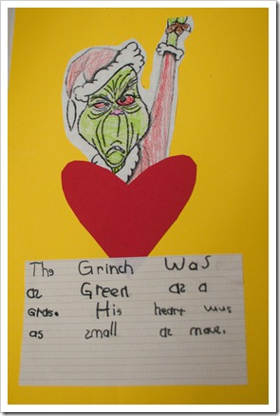
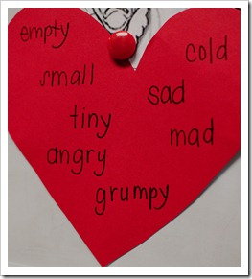
HOT ?:
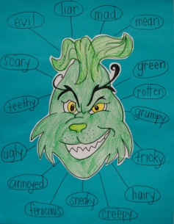
9:45-10:30 Writer’s Workshop
Have students make a Grinch face and on his mouth answer the statement, "I would make a
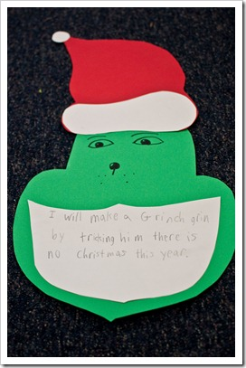
Grinch grin by….” Students should write 5-6 sentences.
HOT ?:
10:30-11:20 Literacy Stations/Guided Reading
11:30-12:00 Lunch
12:05-12:35 Recess
12:40-12:50 Read aloud from chapter book
12:40-1:50
Grinchy Math –
Students will use various leveled story problems to glue into their grinchy math book. Students will create an appropriate equation and show 2 strategies of how to solve each problem. Strategies may include counting up with dots, drawing sticks and circles for tens and ones, creating a math mountain, or drawing a picture for subtraction. If time, students may create their own grinchy word problems to solve.
HOT ?:
1:55-2:40 International Day… Children will rotate to stations to reinforce customs in central America
Give each student a bag of green glitter with this attached:
TO make sure the Grinch doesn’t steal your Christmas, you have to stay on guard. Before going to bed on Christmas Eve, sprinkle this Grinch Dust in your yard. The Grinch will see your magic dust and know you’ve taken care. To protect your home & family and keep Christmas joy in the air!

2:40- 2:50 Class Meeting/Snack/Pack-Up

Theme: Polar Express (Wear Pajamas!)

Wednesday –Word Study Dec. 19th
8:25-8:35 Morning Meeting
- Review LEAD, Mission, Ground Rules, Schedule, Goals, Calendar
- Sing songs to get our brains working
- Word Study – Have student leader choose a sight word from “Mrs. Big Mouth.” Lead students in a cheer for the sight word (baseball style, marshmallow hands, cheerleader, etc.). Ask student leader to dictate a sentence and a question using that word and write them on the board. As a class, read the sentences as the student leader points to the words. Put sight word on word wall.
9:00-9:45 Reader’s Workshop
Read Polar Express. Use Jabber the Reteller to retell the story by using time words to tell events that happened in the beginning, middle, and end. Have children use a flowchart to show the sequenced events. Students drink hot chocolate as they listen to the story.
HOT ?:
Extension: Students try to piece together their own polar express train shapes. This will help with their visual spatial skills.
9:45-10:15 Word Study
- Read/sing poems and discuss main idea, sight words, words that have word chunks, etc.
- Students will review word chunks studied so far by playing a Word Snowball. Children will be given a word family (by spinning the dice). After looking at the given word family, they will write a word that contains that word chunk. Then the player will try to shoot the snowball into the basket for an extra point!
HOT ?:
10:15-11:00 Writer’s Workshop
Students write a persuasive paragraph using a graphic organizer on why they should receive a ticket to the polar express. If students give reasons why, they will get their own polar express ticket!

Read Non-Fiction text about Cocoa. Discuss facts and opinions. Students will put book in order using the following transitional words: First, Next, Then, Last. Then students will retell what they learned about Cocoa.
HOT ?:

Students will create a descriptive poem about hot chocolate using adjectives. Students will share their poem with a partner. The partner will assess the other student on how well they described their hot chocolate with all their senses and on how many adjectives they used. They will give them 2 glows and 1 grow compliment/encouragement.
HOT ?:
11:00-11:35 Snowmen at Night videoconference with Arizona school
Students will share their descriptive stories about what their snowmen do at night (From Monday’s Plans – also they will share their artwork.

11:35-12:05 Lunch
12:10-12:45 Recess
12:45-12:55 Read Aloud from Chapter book
HOT ?:
12:55-1:50 Math
Math Station Games: Hot Chocolate Theme

Dice Roll: Students roll a die for tens and a die for ones. Students record the number that is one less and one more.
HOT ?:
Hot Chocolate Graph: Students will survey the class about what they like to put in their hot chocolate. Students will create their own graph and compare the results using the words “how many more/how many fewer”. Students will analyze their results and write a sentence to summarize their data.
HOT ?:
Roll and Cover: Roll the dice and cover the sum. The first to cover a complete row wins! (For a challenge, students can add to dice, and subtract a third from the sum).
HOT ?:
Roll and Add: Roll two dice and add to find the sum. Graph the sum. The first column filled wins!

HOT ?:
1:40-1:50 Snack and pack
1:55-2:40 Specials
2:40- 2:50 Class Meeting

Thursday Dec. 20
8:25-8:35 Morning Meeting
- Review LEAD, Mission, Ground Rules, Schedule, Goals, Calendar
- Sing songs to get our brains working
- Word Study – Have student leader choose a sight word from “Mrs. Big Mouth.” Lead students in a cheer for the sight word (baseball style, marshmallow hands, cheerleader, etc.). Ask student leader to dictate a sentence and a question using that word and write them on the board. As a class, read the sentences as the student leader points to the words. Put sight word on word wall.
8:35-9:00 – Read “If You Take a Mouse to School” and have students create their own mouse friend to take with them in their pocket. Use grey/white, pink, and black felt, and a string taped for the tail. Have students summarize the story by retelling the beginning, middle, and end in 2-3 sentences.
HOT ?:
9:00-12:00
Movie with the School
12:00 Lunch
12:50-1:50 Winter Celebration
Holiday Workshop – students will rotate through stations that parents have organized.
1:55-2:40 If You Give a Reindeer a Candy Cane…Have students write their own version to the story previously read in the morning. While students are writing, have them create their own candy cane reindeer using 1 candy cane, two googly eyes, 1 brown pipe cleaner for the antlers, and 1 red pom pom for the nose.
HOT ?:
2:40-2:55 Snack and Pack
2:40- 2:50 Class Meeting

Friday Royal Sentences – Fix Up! Dec.21
8:30-8:45 Morning Meeting/Literacy Stations/Guided Reading
- Review LEAD, Mission, Core Values, Ground Rules, Schedule
- Calendar
- Sing songs to get our brains working
- Reread poem to review the meaning. Look for rhyming words in the poem. Circle them. Name other words that could rhyme with them. Read the poem with ease. RF 1.4
10:00-10:45 Chorus Winter Concert
9:00-10:00 Reader’s Workshop
Read Santa’s Stuck and use Jabber the Reteller to retell the story. Have children work in partners to sketch out the beginning, middle, and end. Then, students will create a new suit for santa to disguise him better. Students will write descriptive sentences describing his new suit and explaining/persuading why it would be a better disguise.
HOT ?:
10:30-11:30 Word Study
Play snowman slap (From Monday), snowball throw (from Wednesday), or other word study games.
HOT ?:
11:30-12:00 Lunch- Students will have to eat in the classroom due to early release
12:15 Pack up and prepare for home!

EARLY RELEASE at 12:30!!!!!!
Merry Christmas!!

