What’s the
Temperature?
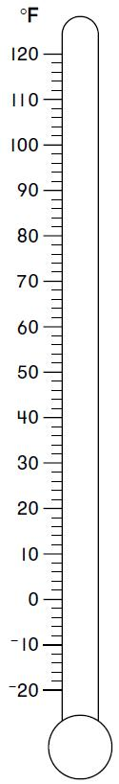

What’s the
Temperature?

What’s the
Temperature?

